✍️ Quick notes

Cohort Call — Week 6 (Hands-On Session 1: AI in the Real World)

Aug 2, 2026
marianna.nechypor@gmail.com sudeunal3334@gmail.com chidioparah@gmail.com yucelala@gmx.de aybenizkadioglu@gmail.com Rifat Erdem Sahin

Session covered artificial intelligence course strategy and forward deployed engineering workflows with hands-on project deployment and future methodologies.

Product Strategy and Monetization
- Proposed shifting from free content models to revenue-generating products (Marianna).
- Identified QA and software engineering as high-demand audiences for AI-based certification.

Forward Deployed Engineering
- Defined forward deployed engineering as the immediate, AI-driven resolution of real-world business problems.
- Identified key required skills: stakeholder communication, project management, and rapid adaptation.

Technical Workshop and Environment Setup
- Used Kanban whiteboard to track personal repository progress and standardize project naming conventions.
- Emphasized public GitHub repositories to build portfolios and leverage star-based visibility metrics.
- Demonstrated CLI workflows: directory management, repository cloning, and project initialization.
- Troubleshot environment setup errors and anti-gravity tool installations across varied operating systems.
- Fostered a collaborative, non-judgmental environment for peer-led technical troubleshooting.

Development Environment Setup
- Reviewed Mac installation methods: DMG, App Store, and Homebrew (Rifat).
- Identified Apple Silicon as optimal for local AI models due to unified memory (Rifat).
- Windows installation requires PowerShell administrative access and Winget package management (Rifat).

Project Deployment and Workflow Efficiency
- Emphasized Day-1 deployment to ensure rapid feedback and integration (Bayo, Rifat).
- Refined workflow to support batching multiple AI commands for faster development (Rifat).
- Utilized GitHub Pages for immediate project hosting and live URL generation (Sudenall, Rifat).

Operational Philosophy and Sustainability
- Defined singularity as human-AI integration, requiring user accountability for troubleshooting (Rifat).
- Confirmed GitHub Actions is free for the first 2,000 minutes with minimal long-term costs (Rifat).

Repository and Cost Optimization
- Strategy identified for utilizing AI to evaluate and terminate unused, cost-incurring repositories (Rifat Erdem Sahin).

AI-Driven Development and Infrastructure
- Recapped usage of GitHub Pages, GitHub Actions, and automation agents in recent workflows.
- Anticipated evolution of tools like Winget and Homebrew toward more agentic, automated functions (Rifat Erdem Sahin).

Forward Deployed Engineering Methodology
- Methodology emphasizes immediate customer integration at project inception (Day 1) rather than late-stage release.
- Demonstrated prototyping speed reaching 4 commits within 5 minutes (Rifat Erdem Sahin).
- Observed that while computing jobs face AI disruption, hands-on engineering roles may remain stable (Bayo Paul Akintunde).

Pedagogical Scaling and Networking
- Shift in teaching model targeting mass audience scale (40,000 students) rather than traditional class sizes.
- Encouraged peer-to-peer networking and mutual teaching to accelerate knowledge retention.

Next steps
- [Marianna Nechypor] Analyze Market Demand: Conduct thorough research on where real interest exists for the educational product.
- [Aybeniz Kadıoğlu] Analyze Amazon Products: Build a data model to evaluate various Fulfillment by Amazon offerings.
- [brian Prosper] Build FBA Crawler: Develop a script that scans e-commerce websites to support logistics operations.
- [Mariana Nechypor, sudenall, Bayo Paul Akintunde, brian Prosper, Aybeniz Kadıoğlu] {Install GitHub}: Download and install the GitHub application on mobile phones to facilitate project management and access.
- [Rifat Erdem Sahin] {Demonstrate Obsidian}: Demonstrate the use of Obsidian to help the team manage their ideas and thoughts effectively.
- [Aybeniz Kadıoğlu] {Share Project Screenshot}: Upload a screenshot of the project initialization to the Kanban board for verification.
- [brian Prosper] Install Anti-gravity: Complete the installation of the anti-gravity tool on the local system. Ensure all dependencies are correctly configured for usage.
- [sudenall, Bayo Paul Akintunde, Marianna Nechypor, brian Prosper] Share Project Links: Post the live GitHub pages URL for the recently created projects into the chat. Make these project sites accessible for review by the team.
- [Bayo Paul Akintunde] Add Database Backend: Implement a database backend for the current AI governance project. Integrate the storage system to enhance project functionality and data management.
- [Rifat Erdem Sahin] Close Unused Projects: Identify and terminate repositories that are inactive but still incurring monthly costs. Utilize AI to assist in the process of closing these projects.
- [Sude, Marianna] Collaborate with Team: Reach out to Brian and Bayou to share project progress and network with the team.
- [Sude, Marianna] Conduct Workshops: Organize and host individual workshops to practice and teach skills within the peer group.
- [Rifat Erdem Sahin] Upload Recording: Post the meeting recording to the designated platform for participant review.

Want to see more? View the full notes
Tip: You can always access your full notes from the left sidebar.

You should review Gemini's notes to make sure they're accurate. Get tips and learn how Gemini takes notes
How is the quality of these specific notes? Take a short survey to let us know your feedback, including how helpful the notes were for your needs.

📝 Full notes
Aug 2, 2026

Cohort Call — Week 6 (Hands-On Session 1: AI in the Real World)
Invited marianna.nechypor@gmail.com sudeunal3334@gmail.com chidioparah@gmail.com yucelala@gmx.de aybenizkadioglu@gmail.com Rifat Erdem Sahin
Attachments Cohort Call — Week 6 (Hands-On Session 1: AI in the Real World)
Meeting records Transcript Recording

Summary
Session covered artificial intelligence course strategy and forward deployed engineering workflows with hands-on project deployment and future methodologies.
Strategy and Core Definitions
The group debated commercializing artificial intelligence education while defining key traits for forward deployed engineers. Participants mapped specific applications to establish clear product development goals.
Technical Implementation and Deployment
Attendees utilized GitHub repositories and artificial intelligence assistants to build, debug, and deploy projects via GitHub Pages. Workflows prioritized rapid iteration and efficient command execution.
Evolution of Engineering
The group examined the changing role of developers regarding artificial intelligence tools and mathematical proficiency. Emphasis was placed on scaling instruction and adopting rapid prototyping methodologies.

Next steps
- [Marianna Nechypor] Analyze Market Demand: Conduct thorough research on where real interest exists for the educational product.
- [Aybeniz Kadıoğlu] Analyze Amazon Products: Build a data model to evaluate various Fulfillment by Amazon offerings.
- [brian Prosper] Build FBA Crawler: Develop a script that scans e-commerce websites to support logistics operations.
- [Mariana Nechypor, sudenall, Bayo Paul Akintunde, brian Prosper, Aybeniz Kadıoğlu] {Install GitHub}: Download and install the GitHub application on mobile phones to facilitate project management and access.
- [Rifat Erdem Sahin] {Demonstrate Obsidian}: Demonstrate the use of Obsidian to help the team manage their ideas and thoughts effectively.
- [Aybeniz Kadıoğlu] {Share Project Screenshot}: Upload a screenshot of the project initialization to the Kanban board for verification.
- [brian Prosper] Install Anti-gravity: Complete the installation of the anti-gravity tool on the local system. Ensure all dependencies are correctly configured for usage.
- [sudenall, Bayo Paul Akintunde, Marianna Nechypor, brian Prosper] Share Project Links: Post the live GitHub pages URL for the recently created projects into the chat. Make these project sites accessible for review by the team.
- [Bayo Paul Akintunde] Add Database Backend: Implement a database backend for the current AI governance project. Integrate the storage system to enhance project functionality and data management.
- [Rifat Erdem Sahin] Close Unused Projects: Identify and terminate repositories that are inactive but still incurring monthly costs. Utilize AI to assist in the process of closing these projects.
- [Sude, Marianna] Collaborate with Team: Reach out to Brian and Bayou to share project progress and network with the team.
- [Sude, Marianna] Conduct Workshops: Organize and host individual workshops to practice and teach skills within the peer group.
- [Rifat Erdem Sahin] Upload Recording: Post the meeting recording to the designated platform for participant review.

Details
Did the screenshots in this section make your notes better or worse?
- Monetization and Course Strategy: Marianna Nechypor and Rifat Erdem Sahin discussed the commercial viability of a potential course. Marianna expressed concern about committing time to a project that generates significant work but minimal income, suggesting a preference for profit-sharing arrangements to ensure financial sustainability. Rifat encouraged Marianna to lead the business strategy, emphasizing that they have the capacity to manage the revenue side while Rifat focused on the content.
- Target Audience and Market Research: Marianna identified a potential target market for AI education, citing a $5,000 course on "AI C-level management" offered by the London Economic School as a benchmark. She argued that the course should target business professionals and IT employees, specifically quality assurance engineers, because they would benefit from AI certification to improve their future work prospects and salary potential.
- Meeting Introductions: Rifat welcomed new participants to the session, including Aybeniz Kadıoğlu, an administrative assistant at the University of Cambridge, and Bayo Paul Akintunde (00:00:38). Rifat also acknowledged other attendees present, including Sudenall and Brian (00:02:22) (00:20:43).
- Workshop Objectives and Process: Rifat explained that the goal of the session was to turn personal AI projects into functional products and certifications (00:01:38). He directed participants to a Kamba whiteboard to map out their individual applications, noting that the session would be highly hands-on with everyone required to develop their own project on GitHub (00:02:22).
- Forward Deployed Engineering Definition: Rifat introduced the concept of a "Forward Deployed Engineer" (FDE), describing them as engineers who utilize AI to solve real-world problems in various sectors, such as finance, the NHS, or the military. He noted that the key foundations for this role are adaptability, problem-solving, communication with stakeholders, and project management, with a core emphasis on being able to deliver results rapidly (00:05:20) (00:08:26).
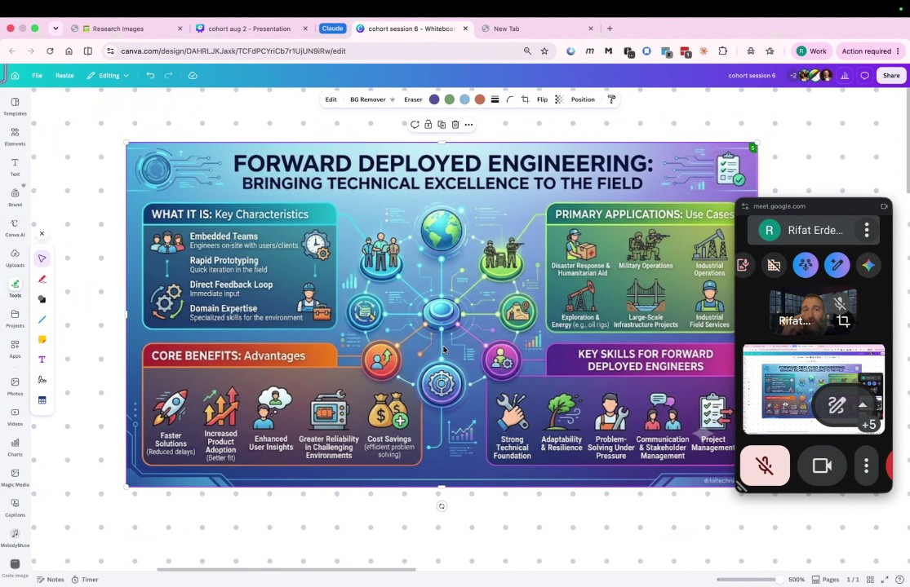
- GitHub Project Creation: Participants were instructed to create individual GitHub repositories for their unique projects, such as an Ireland exploration app or a data science model. Rifat emphasized the importance of initializing these projects with a README file to document the objective, noting that participants should choose between public or private visibility depending on whether they wish to showcase the work in a professional portfolio (00:09:25) (00:11:45).
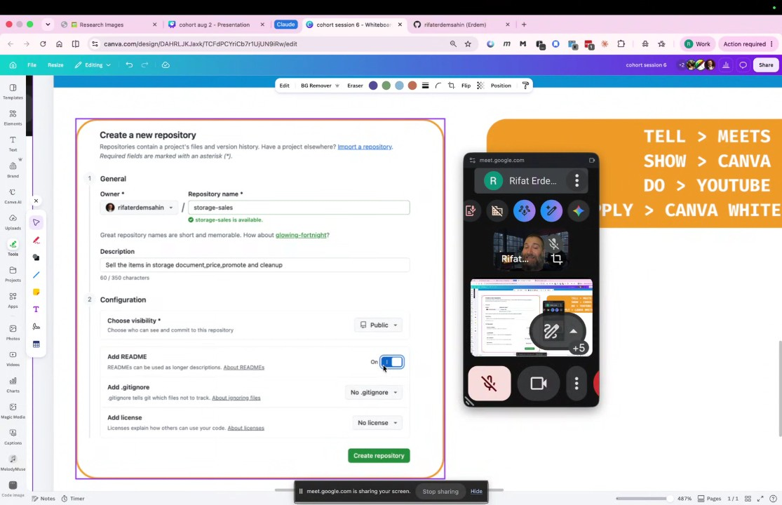
- Repository Visibility and Metrics: Rifat explained that repository stars serve as a metric of confidence and social proof for both companies and potential employers (00:13:33). He warned that changing a repository from public to private would result in the loss of all accumulated stars, which can negatively impact the perceived credibility of a project (00:12:42).
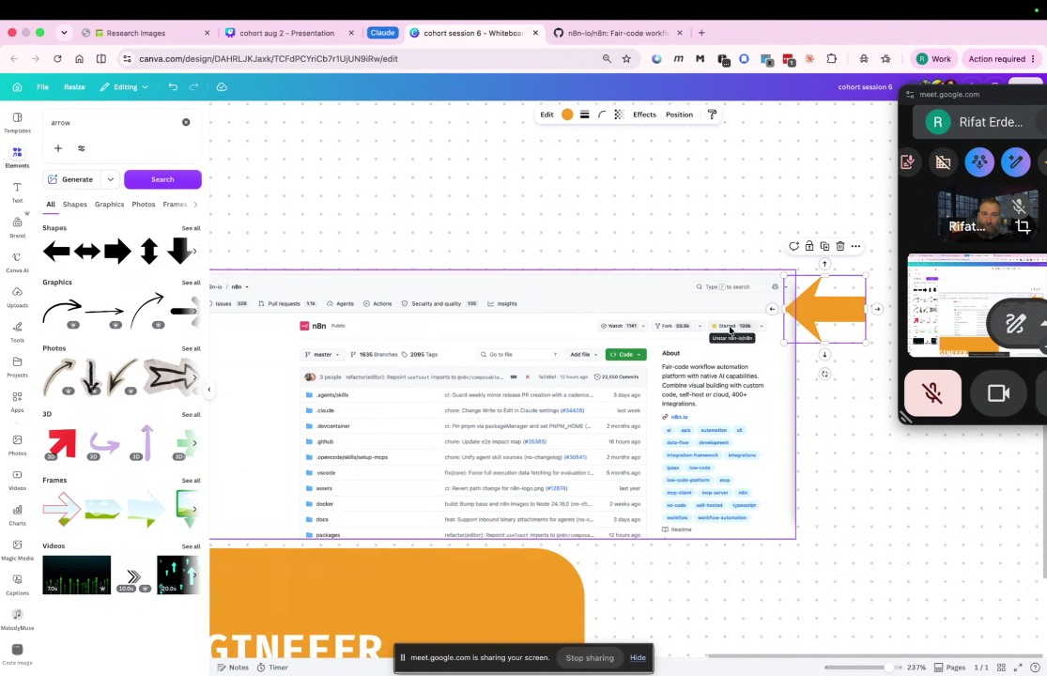
- Project Documentation and Naming Conventions: Participants began adding their project details to the Kamba whiteboard (00:14:32). Rifat provided feedback on naming conventions, advising against generic names like "solution version 01" in favor of descriptive titles that are easier to manage when handling a large volume of repositories (00:16:27).
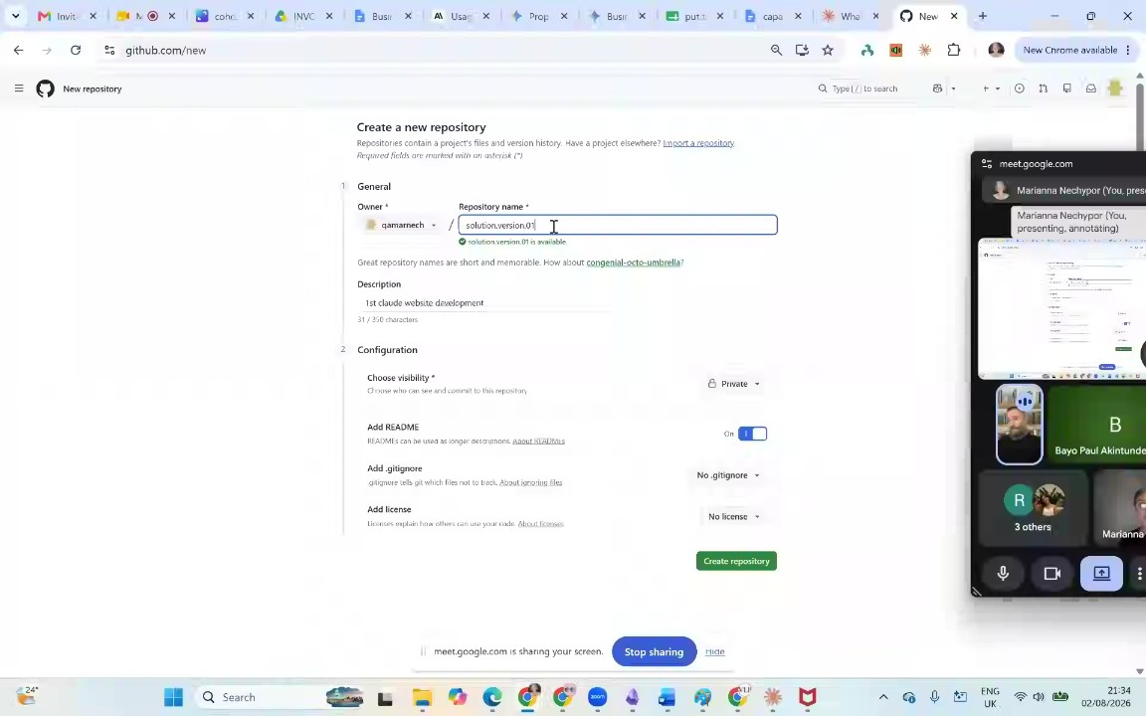
- Initializing Projects and READMEs: Rifat reviewed the work of participants, such as Bayo's "AI governance" project and Brian's "FBA crawler" for Amazon (00:18:25) (00:20:43). He guided them to use the pen icon in GitHub to edit their README files, explaining that a clear explanation of project objectives is a critical skill for an AI engineer (00:19:10) (00:22:45).
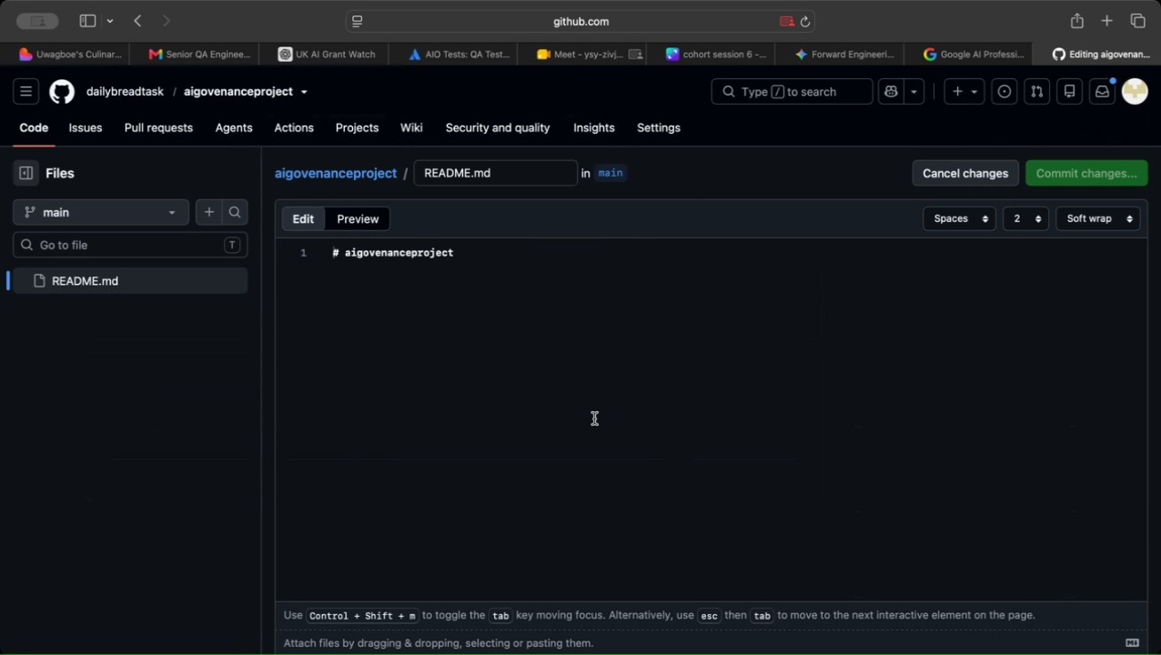
- Committing Project Changes: Rifat explained that GitHub functions as a transactional database and instructed participants to commit their README changes using the green commit button (00:23:43). He stressed that they should aim to use AI to generate the project code rather than writing it manually (00:24:40).
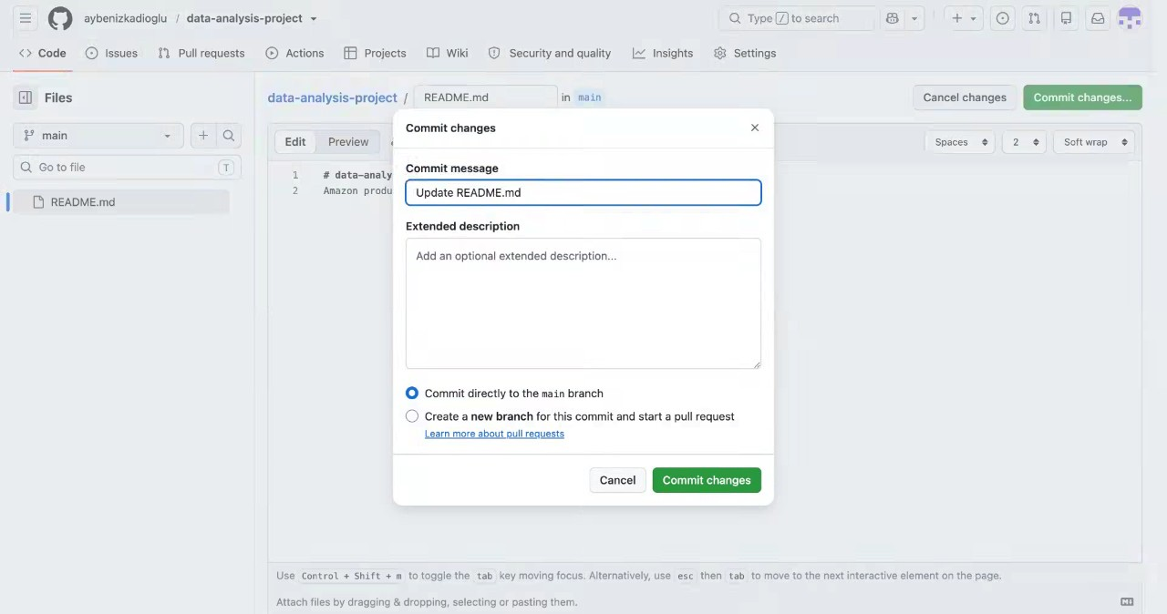
- Cloning Repositories Locally: Rifat demonstrated how to clone GitHub repositories to a local machine using the `git clone` command (00:24:40) (00:26:35). He guided the participants to create a dedicated "projects" directory using the command `mkdir projects` and then navigate into it with `cd projects` to store their work (00:26:35) (00:30:25).
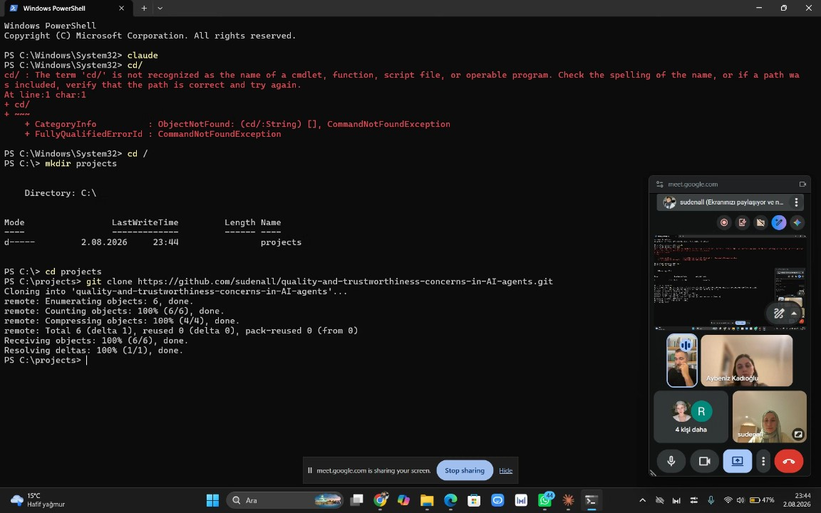
- Technical Troubleshooting and Terminal Usage: Rifat and Sudenall assisted Marianna and Aybeniz with terminal navigation, including using `Ctrl+C` to exit processes and `cd` to change directories (00:29:23) (00:34:03). Participants were shown how to use the `Tab` key for auto-completion of directory names (00:34:03) (00:43:06).
- IDE and AI Tool Selection: Bayo shared his screen using Visual Studio Code, while others explored different AI agents such as Claude and Gemini (00:36:33). Rifat confirmed that participants were free to use various tools—including Visual Studio Code, Claude, Codex, or Gemini—depending on their personal preference and computer environment (00:38:20) (00:44:10).
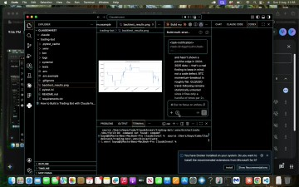
- Installing AI Software: Rifat guided Aybeniz through the installation process for Google Anti-gravity. He advised participants to copy and paste any installation errors they encountered directly into an AI agent, such as Gemini, to receive troubleshooting steps, noting that software installation policies may vary on company-issued laptops versus personal machines (00:44:10) (00:46:17).
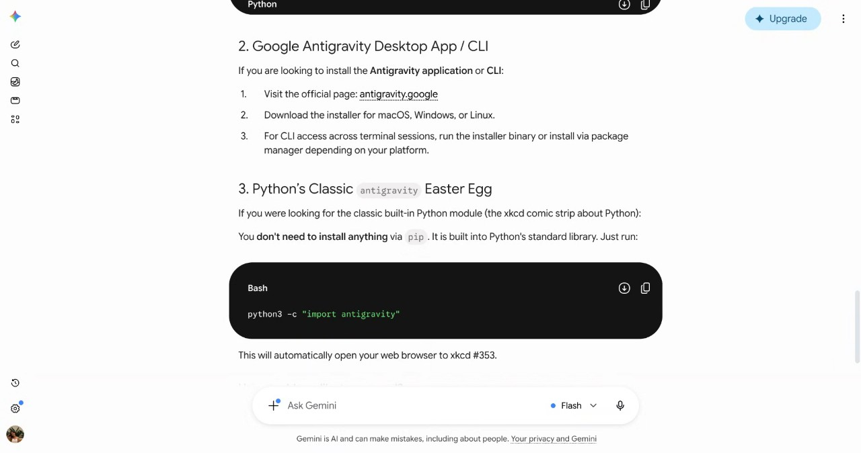
- Second Brain Concept and Culture: Rifat introduced the tool Obsidian for managing ideas and thoughts as a "second brain" (00:41:14). He concluded the session by emphasizing that the learning environment is supportive, reiterating that there is "no shame" in making mistakes, as they are essential for the group to learn collectively (00:52:27).
- Mac Installation Methods: Rifat Erdem Sahin outlines three primary ways to install tools on a Macintosh environment: downloading DMG files from websites, using the App Store, or employing a package manager like Homebrew. Rifat Erdem Sahin notes that when downloading files, users must verify whether their Macintosh uses an Intel CPU or Apple Silicon, as the architecture determines the correct download version (00:54:58).
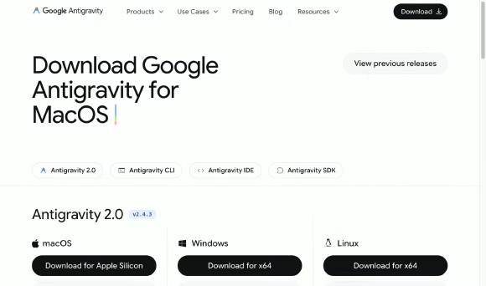
- System Identification and Troubleshooting: Aybeniz Kadıoğlu receives assistance identifying their machine's CPU architecture. Rifat Erdem Sahin explains that most modern Macintosh devices utilize the "M" chip (Apple Silicon), whereas older models utilize Intel chips. Rifat Erdem Sahin suggests checking file sizes to distinguish between available downloads, as the files may appear similar but differ based on the specific architecture (00:56:04) (00:58:19).
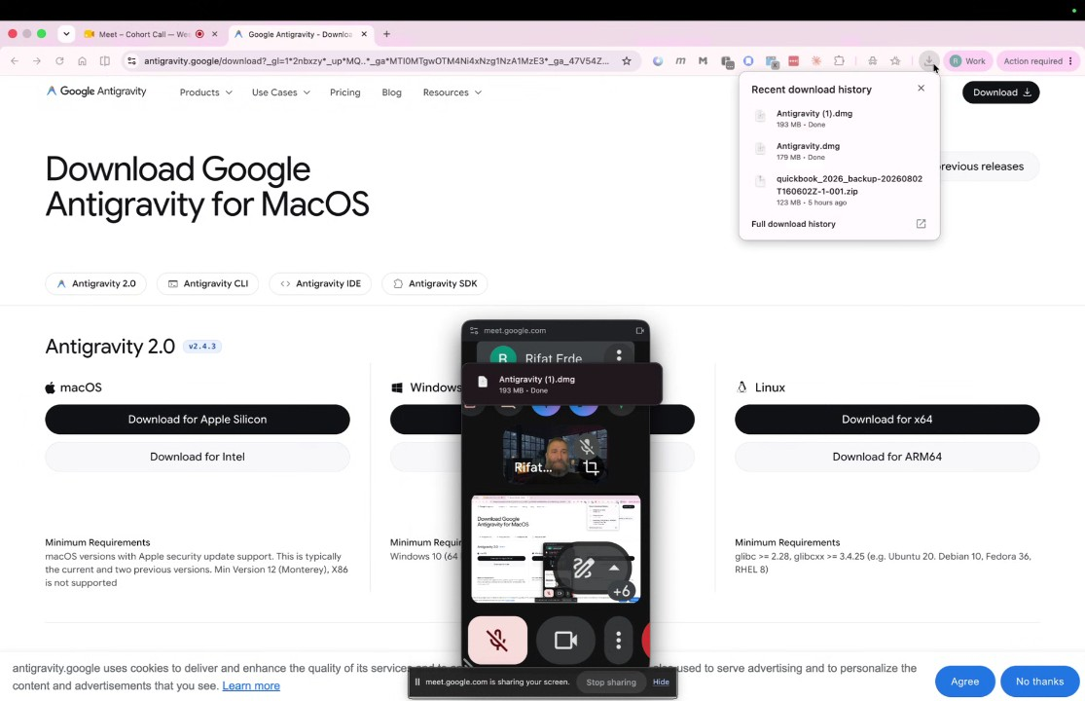
- Installing Anti-gravity: Rifat Erdem Sahin demonstrates the process of installing the Anti-gravity tool. The procedure involves double-clicking the installer, moving the file to applications (or replacing an existing version), and utilizing the Command+Space spotlight search to launch the application. Once launched, the interface serves as an AI-powered copilot for the user (00:59:13).
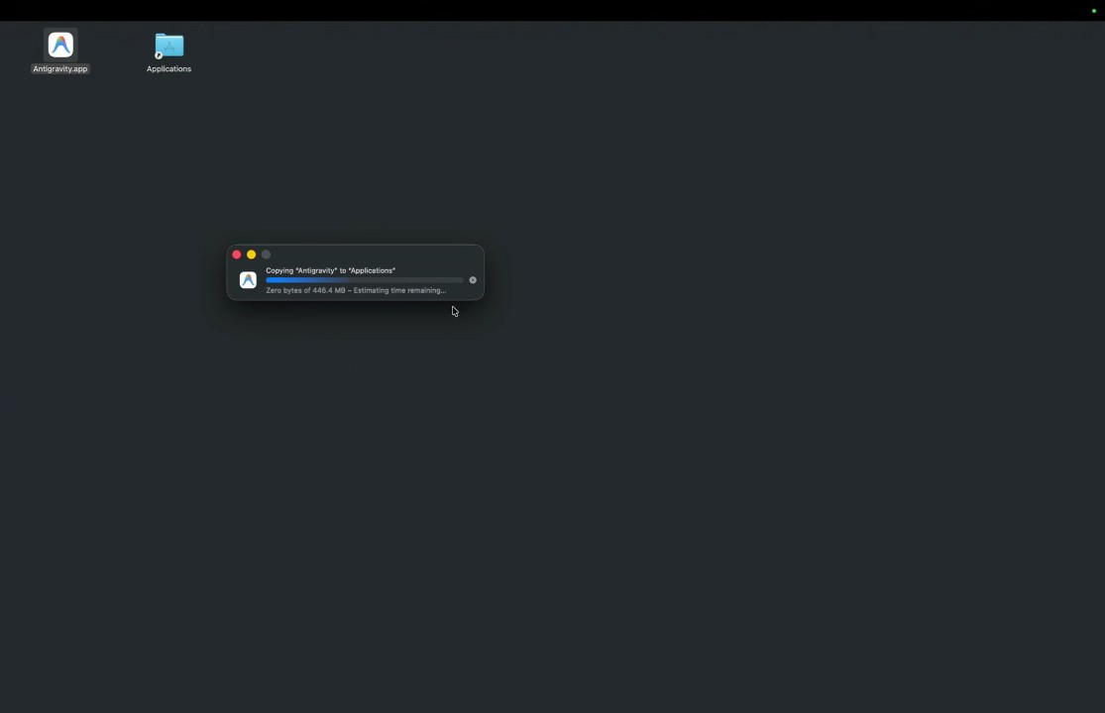
- Hardware Importance for AI Development: Rifat Erdem Sahin emphasizes that Apple Silicon devices are highly advantageous for local AI development because they utilize unified memory, where video memory and system memory are married together. This configuration allows Apple devices to execute larger language models more effectively than standard Intel-based systems (01:00:19).
- Windows Environment Setup: The group shifts focus to Windows environments. brian Prosper shares their screen to proceed with tool installation. Rifat Erdem Sahin guides the setup process, emphasizing the necessity of using PowerShell in administrator mode and teaching fundamental command-line navigation, such as navigating to the root directory using `cd /` and creating folders with `mkdir` (01:02:36).
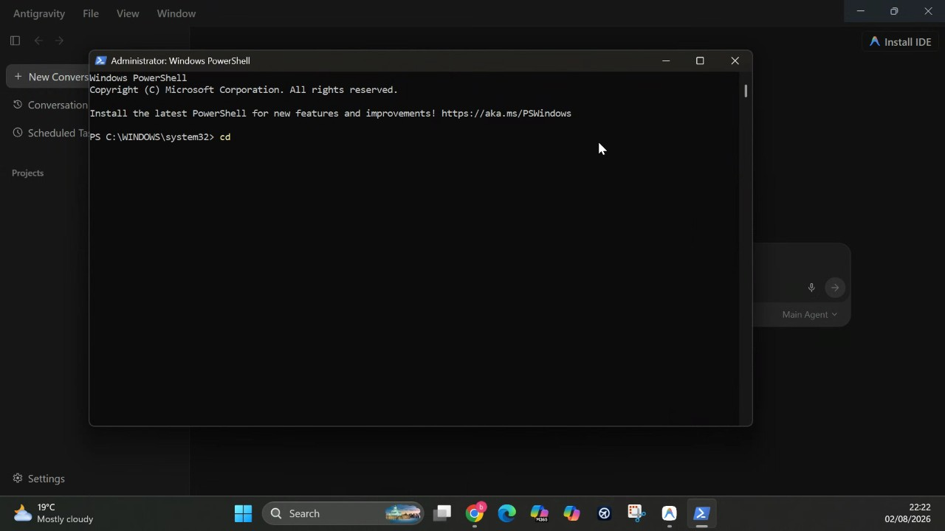
- GitHub Repository Initialization: Rifat Erdem Sahin recommends installing the GitHub application on mobile phones to maintain access when away from the terminal. brian Prosper proceeds to create a new GitHub repository for a "deal sourcing" project. Rifat Erdem Sahin advises using hyphens in repository names and ensuring that a ReadMe file is included for proper documentation (01:05:24).
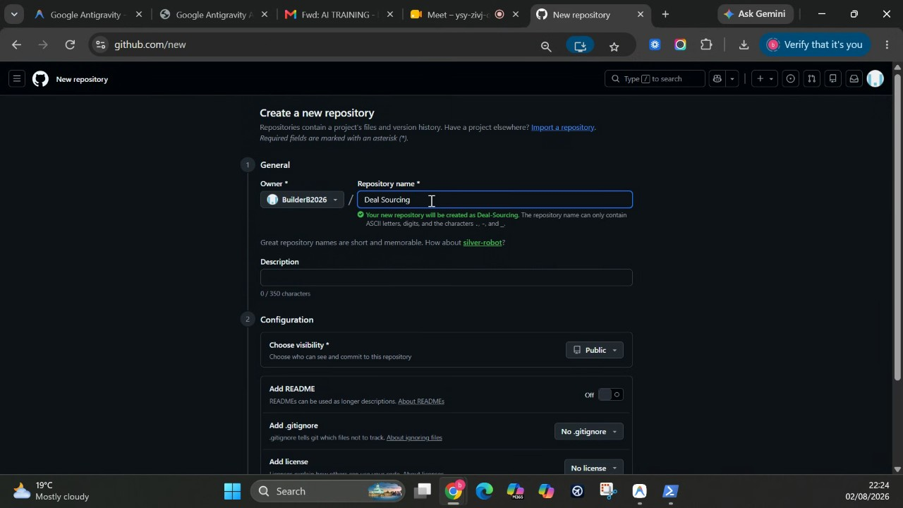
- Debugging Installation Issues with AI: During the project cloning process, the team encounters errors due to missing software tools. Rifat Erdem Sahin explains that rather than manual debugging, users can leverage AI agents, such as Anti-gravity, to automatically detect missing dependencies. Alternatively, users can utilize `winget`, a Windows package manager, to install necessary tools like Git (01:08:25) (01:10:29).
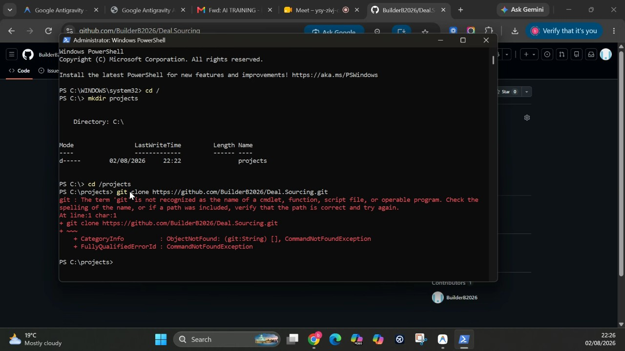
- Terminal Troubleshooting and Singularity: Rifat Erdem Sahin advises closing and reopening the terminal to refresh the environment's memory when errors persist. Rifat Erdem Sahin introduces the concept of "singularity"—where humans and computers become one—and stresses that forward-deployed engineers must remain responsible for solving technical hurdles when AI tools fail to execute tasks (01:13:32) (01:15:29).
- Project Content Generation: sudenall initializes a project focused on AI trustworthiness. Rifat Erdem Sahin guides sudenall through initializing the project and using prompts to create content, such as generating an `index.html` page. Rifat Erdem Sahin advocates for providing sequential instructions, such as asking to "open on this computer" immediately after generating code (01:23:52).
- Managing Token Usage and Cost: Rifat Erdem Sahin explains that AI tools consume "tokens" for every word written. Selecting high-effort models or providing lengthy, poorly structured prompts increases token consumption, which directly impacts costs. Rifat Erdem Sahin advises keeping prompts efficient to manage these expenses when using AI services (01:27:01).
- Deployment to GitHub Pages: To ensure projects are live and accessible, Rifat Erdem Sahin guides the team to deploy their applications using GitHub Pages. By configuring static HTML settings within GitHub Actions, the team creates live URLs for their projects. Rifat Erdem Sahin argues that deploying from "day one" is critical for forward-deployed engineers to gather immediate feedback (01:30:37) (01:34:37).
- Project Functionality and Batching Commands: Rifat Erdem Sahin compares projects created by different participants, noting that functionality varies based on the number and quality of commands given to the AI. Rifat Erdem Sahin encourages the team to "batch" their requests—giving multiple commands at once—rather than single instructions, to accelerate the development process (01:36:38).
- Git Configuration and Workflow: Participants troubleshoot deployment errors related to Git configuration. Rifat Erdem Sahin assists Marianna Nechypor in pushing code changes by ensuring Git is configured with the correct user name and email address. Rifat Erdem Sahin also advises using numeric shortcuts in the AI interface to streamline the workflow and avoid redundant manual clicking (01:39:55) (01:42:44).
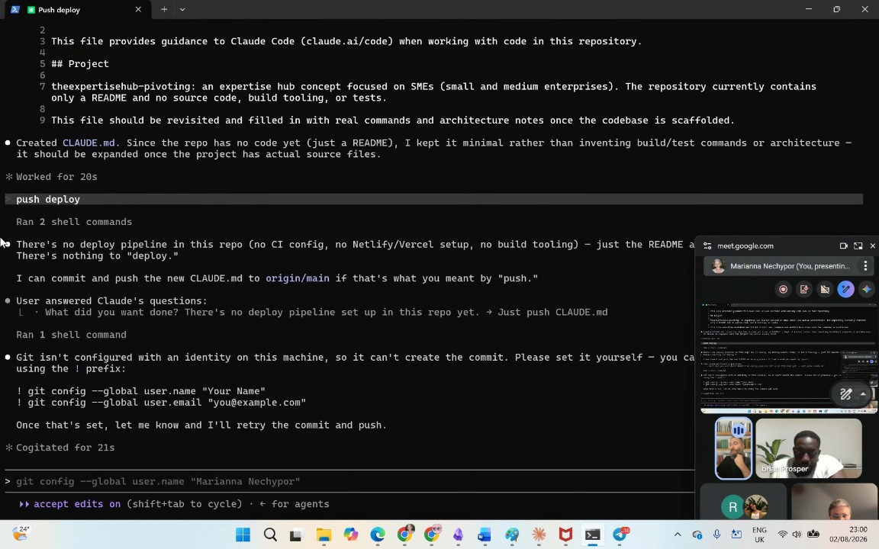
- GitHub Actions and Cost Sustainability: Bayo Paul Akintunde and Rifat Erdem Sahin discuss the costs of using GitHub Actions. Rifat Erdem Sahin clarifies that the service is free for the first 2,000 minutes. Rifat Erdem Sahin reveals that they manage hundreds of machines and pay less than a pound per month due to efficient usage practices, demonstrating the cost-effectiveness of these tools when managed correctly (01:49:00) (01:50:56).
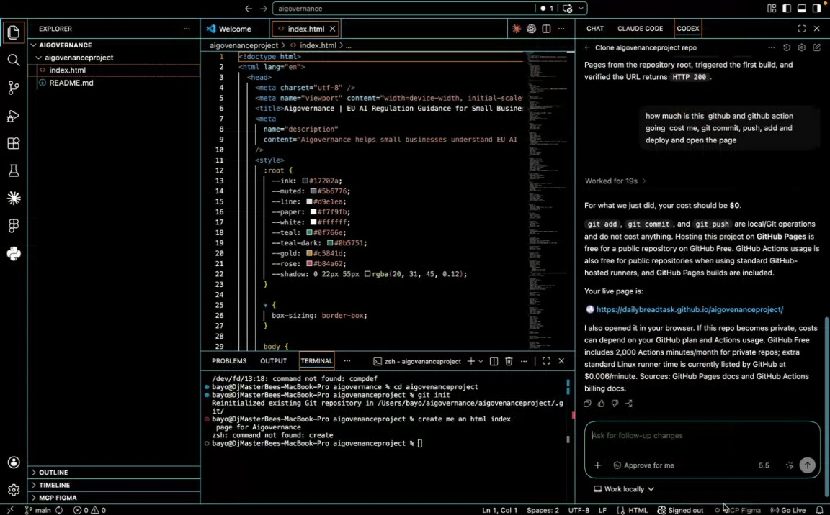
- Repository Management and Project Cleanup: Rifat Erdem Sahin reviews their collection of repositories, specifically noting animation and customer support resolution projects that are no longer active. They express the intent to use AI to identify and close these unused projects to stop paying for them, while maintaining other live projects and deployments (01:53:04).
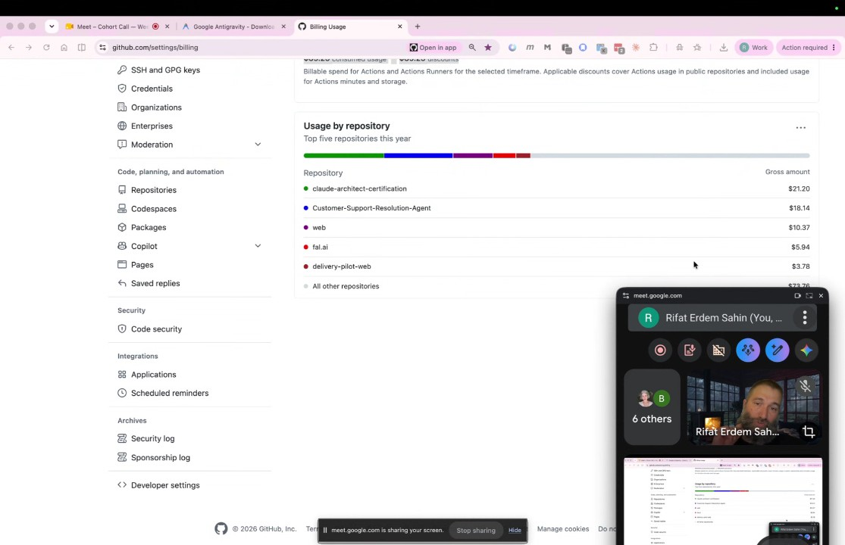
- Recap of Today's Technical Session: The group reviews the key technologies covered during the session, including the creation and deployment of an HTML page. Rifat Erdem Sahin explains that tools such as GitHub Pages, GitHub Actions, Winget, and Homebrew are essentially "agents," and they note that these tools will become increasingly automated and agentic in the future (01:54:15).
- Coding and the Role of Mathematics: Rifat Erdem Sahin discusses the evolving landscape of software development, suggesting that developers will write less code in the future. They compare the relationship between developers and AI to that of a user and a calculator, emphasizing that one must still understand the underlying concepts—such as mathematics—to effectively utilize these tools (01:55:24).
- Future Job Prospects and AI: Bayo Paul Akintunde discusses the potential impact of AI on the job market. They suggest that while it is difficult to predict future outcomes, roles focused on computing and data processing may be heavily affected, whereas hands-on engineering roles may remain more stable (01:55:24).
- Speed and Methodology in Forward Deployed Engineering: Rifat Erdem Sahin demonstrates their workflow for forward deployed engineering, showcasing the ability to make four commits and deploy a project in less than five minutes. They highlight the importance of being able to rapidly prototype, diagnose errors, and fix issues as a core skill for this engineering approach (01:56:37).
- Customer-Centric Deployment Principles: Rifat Erdem Sahin contrasts the traditional engineering pipeline, which involves building and shipping a product before it reaches the customer, with the forward deployed engineering model. They explain that by treating the students as the customers from the first day of the course, they are able to achieve immediate project visualization and insight generation (01:57:37).
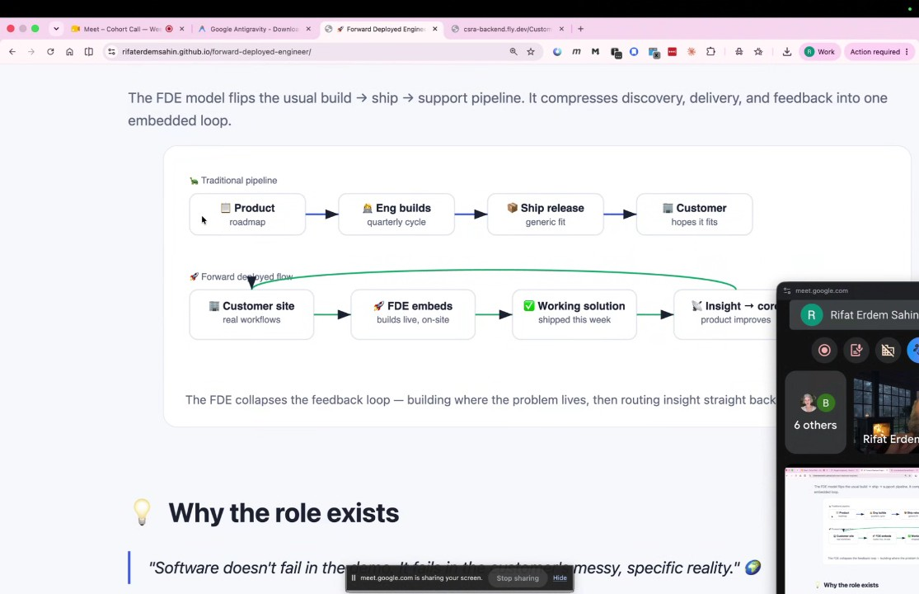
- Collaboration and Educational Scaling: Rifat Erdem Sahin encourages the participants—including Sude, Marianna Nechypor, Brian Prosper, and Bayo Paul Akintunde—to collaborate, conduct their own workshops, and create a network based on their shared time zones. They explain that teaching is a highly effective way to learn, and they reflect on a shift in the modern educational model where teachers must be capable of scaling their instruction to 40,000 students rather than the traditional 40 (01:58:44).

You should review Gemini's notes to make sure they're accurate. Get tips and learn how Gemini takes notes
How is the quality of these specific notes? Take a short survey to let us know your feedback, including how helpful the notes were for your needs.

📖 Transcript
Aug 2, 2026

Cohort Call — Week 6 (Hands-On Session 1: AI in the Real World) - Transcript

00:00:00

Marianna Nechypor: affects their you know their future they have that need and I believe they don't know lots of things because you know why because they are very busy with with doing their daily daily tasks as you how how much time do you
Rifat Erdem Sahin: Yes.
Marianna Nechypor: spend to learn more and to do things because you are you are a you are amazing because I've been thinking today I would love to, you know, to be so motivated as you are. Oh, we have a new Hello.

00:00:38

Aybeniz Kadıoğlu: Hello. Hello.
Marianna Nechypor: Hello.
Rifat Erdem Sahin: Hello.
Marianna Nechypor: How are you?
Aybeniz Kadıoğlu: I am good, thank you. How are you?
Marianna Nechypor: Good. Where are you from? Because Erdem is is gathering people from the
Aybeniz Kadıoğlu: I am from I am from
Marianna Nechypor: world.
Aybeniz Kadıoğlu: Turkey.
Rifat Erdem Sahin: She lives in Cambridge.
Marianna Nechypor: I living
Rifat Erdem Sahin: Uh she is she lives in Cambridge.
Aybeniz Kadıoğlu: Yeah.
Rifat Erdem Sahin: And which school are you going to? I
Aybeniz Kadıoğlu: Anglar Askin. I graduate Anglaraskin
Marianna Nechypor: Ah,
Aybeniz Kadıoğlu: University.
Rifat Erdem Sahin: uh
Marianna Nechypor: but I I but currently are you in Turkey?
Aybeniz Kadıoğlu: No, in Cambridge. I'm in Cambridge now.
Marianna Nechypor: I can hear as well. Amazing.
Aybeniz Kadıoğlu: Oh, nice.
Marianna Nechypor: What are you
Aybeniz Kadıoğlu: I'm currently I'm currently working Cambridge University,
Marianna Nechypor: doing?
Aybeniz Kadıoğlu: University of Cambridge as admin assistant.
Marianna Nechypor: Ah, great. We have two dams.
Aybeniz Kadıoğlu: Thank you.
Marianna Nechypor: I do think that people from your space would would they like to learn to learn more about AI?

00:01:38

Bayo Paul Akintunde: Hi.
Aybeniz Kadıoğlu: Yes, exactly.
Marianna Nechypor: Hi
Bayo Paul Akintunde: Hi. Yeah.
Rifat Erdem Sahin: Hello Bayo how are
Bayo Paul Akintunde: Hello.
Marianna Nechypor: Ba.
Aybeniz Kadıoğlu: Hello.
Rifat Erdem Sahin: you?
Bayo Paul Akintunde: I'm good. I'm good. Yourself? That's how we on my right now?
Rifat Erdem Sahin: Better than I deserve by you. Better than I
Bayo Paul Akintunde: Yeah.
Rifat Erdem Sahin: deserve.
Bayo Paul Akintunde: We've got two of you today. One here, one
Rifat Erdem Sahin: Yes.
Bayo Paul Akintunde: here.
Rifat Erdem Sahin: Uh this one is going to go for uh becoming a Santa. The other one will become the smurf because I'm uh we
Bayo Paul Akintunde: Okay.
Rifat Erdem Sahin: have this uh what's it called? Uh challenge. Uh I want to be able to turn this into certification into a product. Uh hopefully.
Bayo Paul Akintunde: Yes.
Rifat Erdem Sahin: Hello Sud. So I'm growing the beard and I don't like the beard.

00:02:22

Rifat Erdem Sahin: I need to cut the beard once this thing becomes a reality. I want to be able to use the AI and be able to turn this into a business by as a business. How are you Sud? Uh we can't hear you. Sudi, you are muted. Uh Sudi is also in Ireland.
sudenall: Hi.
Rifat Erdem Sahin: I guess everybody's is in the same uh time zone.
sudenall: Sorry.
Rifat Erdem Sahin: We are recording the calls for everybody's info. Then we are uploading them to the portal. I today I will be sharing uh my screen and this today is going to be a lot of hands-on uh session uh that we are going to do. I will share two links. One ka whiteboard link uh where I will put everybody's uh name onto the ka whiteboard. Uh and the other thing is going to be the ka presentations. We are going to do a application on GitHub. Everybody will do their own application and I will do my own application.

00:03:23

Rifat Erdem Sahin: We will use the AI to be able to see uh what kind of an application that we can do. 5 minutes. Uh feel free to watch the previous sessions uh that we are doing. We are doing this around 2 hours in the London time. We are ending this around 11 p.m. But if anybody needs to go uh they can definitely go as well. I will say cohort uh session 6. Uh I will uh share the link on kama on here. Uh so everybody should be able to come in and edit in this session. I will put the session link over there uh into the chat. So everybody should be able to access. If you guys have questions, feel free to ask. Today it is mostly going to be hands- on uh doing the action. I will ask everybody to be able to do a hands-on. I will share my screen and you guys should be able to come in uh on to the coma whiteboard right now.

00:04:23

Rifat Erdem Sahin: Are you guys able to see my screen?
sudenall: Yeah.
Rifat Erdem Sahin: So I'm looking at the people on the top please in Kamba uh put your names
Aybeniz Kadıoğlu: Yeah.
Rifat Erdem Sahin: on here. So I can see I here I don't know who sea turtle is I know the sud everybody uh put their applications over here. This is going to be like a mind map uh that we are going to use. What does a mind map means? Such as we are going to have this hands-on session. I will take a screenshot from here and for this cohort session I will make sure that uh I will put an image next to my face over there. So this is my section over here. The left hand side is going to be Aybeniz's section. The right top left top is going to be Mariana. uh the north section is going to be sudenall and the right top is going to be
sudenall: Thank
Rifat Erdem Sahin: Bayo section over here.

00:05:20

sudenall: you.
Rifat Erdem Sahin: So let's jump in and let's start what we are going to do. What we are going to develop today is going to be the key part. We are going to create a GitHub repository and solve one of our problems. This is called uh forward deployed engineering. Uh did anybody of you guys heard this term? It is called forward deployed engineering. FD uh E forward
Marianna Nechypor: Go forward. Deploy engineering.
Rifat Erdem Sahin: yes deployed engineer. So does anybody know this term?
sudenall: No.
Rifat Erdem Sahin: So how can we learn how to uh how does this term make sense? We can go to Gemini and learn this. So the share your screen and show us how you can learn this forward deployed engineer means so everybody knows what this concept means. I will stop my share so Sud can share her screen. Can everybody see Sud screen?
Bayo Paul Akintunde: Yeah.
Rifat Erdem Sahin: I have stopped my share.

00:06:31

Rifat Erdem Sahin: Now Sudi is sharing. Yes. What we say it is in Gemini. We learned last week. Gemini is a multimodel omnimodel system. We will go to Gemini and say create me an infographic. Infographics is the visual ways for us to be able to learn the things with ease. So anybody who has not done that in the past can definitely do this and it is going to create us a forward deployed engineer. On the right top there's a copy button. So they copy this image and put it to the combas so everybody can see it in detail and make sure that you are putting to your face on top. Yes, over there. Make sure that it is linked with you. So why should bioh zoom it in it so bio can see it easily. I can see it. Why should bio focus on forward deploy the engineer? So let's make it a little bit zoom in. Zoom in so we can see.

00:07:30

Rifat Erdem Sahin: Don't make it too big. So because this is an infinite combass, I will share my screen and show how this is working. So come back to my screen. I will make sure that everybody's able to do this with ease.
sudenall: Okay.
Rifat Erdem Sahin: So I I'm here. I maximize this. I'll put this on the left hand side so everybody can see this on here because this is an infinite commas on the left right button uh there's a percentage that is written on here what you can do it is you can make this smaller I will hold this uh and make this smaller uh but then I will zoom into here so as you guys see there is a zoom
sudenall: Mhm.
Rifat Erdem Sahin: feature on the right button so I can line up to the space uh on here and not make it way too big. So what does the forward deployed engineer means? A forward deployed engineer is an engineer who can use the AI and make things work.

00:08:26

Rifat Erdem Sahin: So that is what does forward deployed engineer means. You guys are going to use the AI and use the AI at your work to be able to do real world AI applications. If this is an army, you guys do army stuff. If you guys are working in NHS, you guys do it for NHS. If you guys are working in finance, you guys should be able to work in finance and be able to do it. What are the key skills, key foundations for the AI? You guys should be able to adapt, use problem solving, communicate with the stakeholders and project management. So at day one they will ask bayou build me a finance system and the bayou will directly build a finance system. They will ask sud build me a gallery of all my images. Sud should be able to do this because the core feature is her being fast to be able to do this not like learn about this but fast at day one to be able to do this.

00:09:25

Rifat Erdem Sahin: So this is called a forward deployed engineer. So everybody what I expect from everybody is to be able to go to GitHub in the first step and create their own repositories. How we are doing it? Everybody to go to GitHub first and we are going to deploy a project for ourselves. So why do we want to be able to create a project for ourselves and everybody going to have a different project. Everybody is going to go to GitHub and create their project. And I expect I's project to be different than Bayou's project. Bio's project to be different than Sudes project. Why do we want to create a personal project? Mariana, what do you think?
Marianna Nechypor: a personal project.
Rifat Erdem Sahin: Yes, a personal project.
Marianna Nechypor: No,
Rifat Erdem Sahin: I have Yes.
Marianna Nechypor: because I am really happy that we are doing that because uh then I can create for example the website through the GitHub and when I'm doing with a with a clot it's better it definitely better because I have more things under control than when I do it with lovable for example or I can I can help myself with lovable but still I think that claude can create like a whole system I and add a different models,

00:10:47

Rifat Erdem Sahin: Yes, you guys are uh building or creating the project in the background coming up with the idea and
Marianna Nechypor: right?
Rifat Erdem Sahin: creating the GitHub project. But you can say I want to work as a DJ or I want to work as an Uber driver or I want to do X. I don't know anything that BU wants to do. I want to create the new Google. Create a go to the GitHub and create your new GitHub project. I says I want to be the data scientist. I want to create data models. Create your data model project. Suda says I want to explore Ireland with with my friends. Create an Ireland explore project. I have more than 450 projects plus every day I
sudenall: All
Rifat Erdem Sahin: create around one or two projects. I want you guys to come up with your own idea and to be able to create your own project. Once you guys create that project, uh what we are going to do it is we will come back to this board guys, girls and put the project like this next to your name.

00:11:45

sudenall: right.
Rifat Erdem Sahin: Uh my project is storage sales. I created my project. Uh please add the readme file at the start. Uh, so it is easier for you guys to be able to interact and get the project for yourself. So this is going to be the major thing for you because the next command that we are going to work on is g clone uh is the pro the command that we are going to work on our project g clone xxx
Marianna Nechypor: A visibility.
Rifat Erdem Sahin: yes please paste it on here. Sorry, Mariana.
Marianna Nechypor: A visibility. You said add read me.
Rifat Erdem Sahin: Public, public, public every everybody.
Marianna Nechypor: Why?
Rifat Erdem Sahin: You can either sell it public or private. If it is going to be private, you can also do it private. If it is a private matter, you are going to uh follow up.
Marianna Nechypor: I wanted the private for
Rifat Erdem Sahin: Uh do it for private, do it for private.

00:12:42

Rifat Erdem Sahin: If it is going to be some secrets that are going to be shared,
Marianna Nechypor: now.
Rifat Erdem Sahin: please make it private. But uh this is like your portfolio. What I prefer it most of the time is I make them public so I can use that as a portfolio when I go to contracts customers that I can demonstrate this with
Marianna Nechypor: But I always can change can change to
Rifat Erdem Sahin: Morris. Yes, it can always change to public.
Marianna Nechypor: public.
Rifat Erdem Sahin: You can start with uh you can start with uh public then go to private or start with private and then go to public. What is the problem of changing these guys? What happens once you change it by the public to private?
Bayo Paul Akintunde: Well, uh, nobody else will have access to it if it's not public, you know.
Rifat Erdem Sahin: Yeah.
Bayo Paul Akintunde: So,
Rifat Erdem Sahin: Yes.
Bayo Paul Akintunde: dependency.
Rifat Erdem Sahin: Very good. You guys are going to lose your stars in the repository.

00:13:33

Bayo Paul Akintunde: Yes.
Rifat Erdem Sahin: So what does that mean? Uh losing stars. If I go to any repo such as NAN repo, this repo is a public repo. this NA10 repo. Everybody sees how many stars do they have? 200,000. Does everybody see 200,000 stars? If they change this to private, it will lose all of the stars. So, all the public uh action will go away. So, I will put this on here.
Marianna Nechypor: You mean that it's important when if you are looking for a job and you are building your portfolio.
Rifat Erdem Sahin: So, also customers, not only a job,
Marianna Nechypor: Yeah.
Rifat Erdem Sahin: this is a company.
Bayo Paul Akintunde: Yes.
Rifat Erdem Sahin: NA10 is a company. They have a public product and they want these stars because these stars gives confidence to the people. I know that there is 1,000 people watching this repository every single day. Any code comes in, they see it on their stuff.

00:14:32

Rifat Erdem Sahin: 60,000 people created their own version of this project and 200,000 people said this is a good repository to see. So uh if you change it from public to private then we are going to lose that aspect. I don't see people pasting the action. Bayou did thank you Bayou Bayou did it on here. His is quality and trustworthiness concerns in AI agents.
sudenall: It's mine.
Rifat Erdem Sahin: Very good. Where is your sudenall?
sudenall: It's mine.
Rifat Erdem Sahin: Suda put it on top of your name.
sudenall: Oh,
Rifat Erdem Sahin: You are going on top.
sudenall: sorry.
Rifat Erdem Sahin: This right hand side is belonging to Bayo.
sudenall: Oh, okay.
Rifat Erdem Sahin: Uh this I will put the this is Bayo bayou's part is this part.
sudenall: Okay.
Rifat Erdem Sahin: The other part is your part. So this is going to become like a flower. So this is all this part is Bayo.
sudenall: Mhm.
Rifat Erdem Sahin: I you can put the GitHub repository to write left button uh to yourself on here.

00:15:30

Bayo Paul Akintunde: Is it just
Marianna Nechypor: Guys,
Bayo Paul Akintunde: text?
Rifat Erdem Sahin: Yes. Uh I uh yes Bayo please go ahead.
Marianna Nechypor: what
Bayo Paul Akintunde: Is it just text?
Rifat Erdem Sahin: Sorry I interrupt here screenshot because on
Bayo Paul Akintunde: Uh just the link you want or screenshot.
Rifat Erdem Sahin: here we only uh share knowledge on the whiteboard as a screenshot. So we can see from each other what we have done. Are
Bayo Paul Akintunde: Okay.
Aybeniz Kadıoğlu: Just give me a second please. I am searching it.
Rifat Erdem Sahin: hold the event down. Uh but that should be all right. Everybody's in the call and I hope we are still recording it. Yes. Uh please paste the screenshots. Aybeniz, would you like to share your screen?
Aybeniz Kadıoğlu: It is not ready. Not now.
Bayo Paul Akintunde: Yeah.
Aybeniz Kadıoğlu: Test me please now.
Bayo Paul Akintunde: One second.
Rifat Erdem Sahin: Mariana, would you like to share your screen?

00:16:27

Marianna Nechypor: Yes, absolutely. Give me a second. I'm copy pasting here. Um Oh, this is mine.
Rifat Erdem Sahin: All right. Share your screen so we can see to come up with an idea should not be hard such as I'm doing ice cream
Marianna Nechypor: Um, this one. This
Rifat Erdem Sahin: solution. This is the hold on hold on I will give you a feedback.
Marianna Nechypor: one.
Rifat Erdem Sahin: If you put like a ice cream factory that is even a better name. How are you going to remember the solution version 01? You always have a new solution. You always have a new version. You cannot recall this project by remembering it. Uh the Brian from Nissa. Hold on. Uh yes. Uh come up with a better name. Come up with a better name. Come up with a better name, please. Yes. U who wants to share their screen?

00:17:41

Rifat Erdem Sahin: Uh by you would you like to share your screen so we can see that you
Bayo Paul Akintunde: Yeah. Yeah,
Rifat Erdem Sahin: can create it and paste it.
Bayo Paul Akintunde: I think. Okay, sure.
Marianna Nechypor: But the rest, give me a second.
Rifat Erdem Sahin: Uh no,
Marianna Nechypor: Sorry.
Bayo Paul Akintunde: Go.
Marianna Nechypor: But the rest add gyign add
Rifat Erdem Sahin: you don't need to change those.
Marianna Nechypor: life.
Rifat Erdem Sahin: Just add a read me. That's enough. Uh that's enough for us. Yes.
Bayo Paul Akintunde: Yep.
Rifat Erdem Sahin: Create the repository. That is good. uh in the GitHub repository names. Uh don't give uh spaces that's also important.
Marianna Nechypor: Okay.
Rifat Erdem Sahin: Give unique names that is also very critical and very important for everybody to know. So the better the names that you guys give, it is easier uh for you to remember. As I said, I have 400 plus repositories.

00:18:25

Rifat Erdem Sahin: But would you like to share your screen? Did you add your image?
Bayo Paul Akintunde: Yes.
Rifat Erdem Sahin: But you already did.
Bayo Paul Akintunde: Do you is it a repo screen you want to share or the
Rifat Erdem Sahin: Yes. Repo the daily bread task.
Bayo Paul Akintunde: camera?
Rifat Erdem Sahin: Is that your repo by it?
Bayo Paul Akintunde: Yeah. No, my one is the AI governance
Rifat Erdem Sahin: AI governance. Please put it. Yes. Over there.
Bayo Paul Akintunde: is there.
Rifat Erdem Sahin: The solution uh mesh on here. Giving good names is very critical guys and girls.
Bayo Paul Akintunde: Yeah.
Rifat Erdem Sahin: That is very very important to be able to give it a good name because the future right now
Bayo Paul Akintunde: window.
Rifat Erdem Sahin: is people will build all these excessive number of repositories that they need to name properly for the future. Yes.
Bayo Paul Akintunde: So that's my that's my ripple AI
Rifat Erdem Sahin: Yes.

00:19:10

Bayo Paul Akintunde: governance.
Rifat Erdem Sahin: Yes. The thing is what Bayou didn't do it is Bayou did not add a readme file. He bypassed that step. So what we see it on here is uh he's unable to edit this project directly. If you guys add the readme, the GitHub gives you guys the feature to be able to edit the readme very easily. Why do we care about this? Because as a former deployed engineer, an AI engineer who comes to the role should be able to uh give uh edit these stuff very easily. Someone would like to join. Uh Brian, Brian is coming. Uh yes. Now put the add readme button. Hello Brian. How are you today? Yes,
Bayo Paul Akintunde: All
Rifat Erdem Sahin: add read me. Add read me. Yes.
Bayo Paul Akintunde: right.
Rifat Erdem Sahin: Very good. Create the repository. All right.

00:20:05

Rifat Erdem Sahin: Perfect. Uh Brian, we cannot hear you. I hope you can hear us. Yes. The good part on here is by you. Uh there is a button over there. There's a pen icon over there. Please click that pan icon.
Aybeniz Kadıoğlu: Where's
Rifat Erdem Sahin: Click that pan icon on the right button.
Bayo Paul Akintunde: Sorry,
Rifat Erdem Sahin: Right button. Right, down, left, left, left,
Bayo Paul Akintunde: sorry, I'm lost.
Rifat Erdem Sahin: left.
Bayo Paul Akintunde: Watch. Am I in the right place?
Rifat Erdem Sahin: Below the green code button, there is a pen icon.
Bayo Paul Akintunde: Okay.
Rifat Erdem Sahin: Pen icon. Pen icon. A little bit.
Bayo Paul Akintunde: Pen icon. All right. Okay.
Rifat Erdem Sahin: Yes. Yes. Here. Explain what this project does uh in a nutshell.
Aybeniz Kadıoğlu: Awesome.
Rifat Erdem Sahin: What do you want this project to do?

00:20:43

Rifat Erdem Sahin: Everybody has to do that in their own readme. Please uh write what your project is going to do at your readmi please.
Bayo Paul Akintunde: Thank you.
Rifat Erdem Sahin: All right. Uh, so Brian, what we are doing is everybody is creating their own GitHub project. If you can hear us,
Aybeniz Kadıoğlu: That's
Rifat Erdem Sahin: create your GitHub project. Then add a readme file.
brian Prosper: Yep.
Rifat Erdem Sahin: What you want that project to do? You told me that you want the write a crawler project from Amazon websites to be able to do the FBA. You can call it FBA crawler. We want to be able to do your project and commit the changes once it is done. This project is helping business uh small businesses understand the regulations.
Bayo Paul Akintunde: Hm.
Rifat Erdem Sahin: Very good. Once you guys write it, you guys are going to commit it. Take a screenshot window shift 4 and edit uh add that what's it called?

00:21:48

Rifat Erdem Sahin: Uh ka whiteboard. I will send you the ka link as well. uh Brian that you should be able to add your images over there and I will open up a section for you in the system so you can add your uh images
Bayo Paul Akintunde: This
Rifat Erdem Sahin: as well. I will put your Brian on the right hand side Brian
Bayo Paul Akintunde: is
Rifat Erdem Sahin: Prosper. All right, I will put your Brian on the right hand side. You can put them uh to the right hand side over here. I put an arrow for you. So, it should be straightforward. All right. Did everybody do that? Uh, I were able to add the readme and create your project.
Aybeniz Kadıoğlu: Yes. I credit
Rifat Erdem Sahin: Yes. Let's share. Let's go to uh your screen.
Aybeniz Kadıoğlu: it.
Rifat Erdem Sahin: IS uh you need to commit uh hit the
Bayo Paul Akintunde: Just going to stop sharing.

00:22:45

Rifat Erdem Sahin: commit button uh by you.
brian Prosper: Oops.
Bayo Paul Akintunde: Yeah. Yep. I just want to stop sharing.
Rifat Erdem Sahin: Make sure that Yes,
Bayo Paul Akintunde: One second. Yep. I'll do that.
Rifat Erdem Sahin: but you for you to finish you need to hit the commit button and make sure it gets committed into the
Bayo Paul Akintunde: Yes.
Rifat Erdem Sahin: system. So everybody is now press the pan icon uh pan icon uh Aybeniz please over there in the read me down below left left down yes over there there's a pen icon yes very good what does this data analysis project do what kind of a data are you going to analyze explain here in the readney what this project does this is called the markdown format MD means markdown So we can easily explain what we are doing on the markdown files. What we want is everybody to have a GitHub account, create a GitHub project that they want to do at the read me and explain the objective of the project.

00:23:43

Rifat Erdem Sahin: What is your objective? I
Aybeniz Kadıoğlu: Uh, I'm not ready to actually my project.
Rifat Erdem Sahin: Yes, let's write it. The data analysis for Amazon products.
Aybeniz Kadıoğlu: Sorry about that.
Rifat Erdem Sahin: Write it.
Marianna Nechypor: He's
Rifat Erdem Sahin: I will give it to you as an example because I know um uh um wants to do analysis on Amazon products. Is that correct?
Aybeniz Kadıoğlu: Yes, you're
Rifat Erdem Sahin: Yes, I will help you on that. You are going to help him with this uh data Amazon products data analysis for
Marianna Nechypor: built.
Aybeniz Kadıoğlu: right.
Rifat Erdem Sahin: an FBA. For an FBA FBA means fulfilled by Amazon FBA.
Aybeniz Kadıoğlu: Maybe these ones.
Rifat Erdem Sahin: Now you hit the green button, commit the changes. G is a transactional database which it means it's going to create a transaction, assign a commit ID and save this. Please hit the commit changes. Commit changes. The green button. Yes.

00:24:40

Rifat Erdem Sahin: Press the green button please.
Aybeniz Kadıoğlu: Sorry, give me a
Rifat Erdem Sahin: Please.
Aybeniz Kadıoğlu: second.
Rifat Erdem Sahin: Yes. Now what you can do it is write an extended description but I don't want you guys to write extended descriptions because we are going to use the AI to be able to do this project for you not some not us writing the project. We will ask the AI to be able to write this project. Please hit commit changes. Commit changes. Now Sud we are going to share your screen and use an AI agent of your choice. You can use codeex, gemini or clo uh and do a g clone uh to your project. Please share your screens today so we can see the g clone process with everybody.
sudenall: Okay.
Rifat Erdem Sahin: We are going to take the project to our computer and ask the AI to be able to get all the files. First of all, where we go is we go to the first uh root of the project.

00:25:44

Rifat Erdem Sahin: Click quality and trustness. Very good. Click on that. Then click on the code the yellow the green icon. Yes. And you are going to copy that https. It says clone. Does everybody see the clone guys? It says clone. I will put that into the into our board.
sudenall: Mhm.
Rifat Erdem Sahin: What sudi is doing is she's going to clone. Which AI agent do you use? Sud Claude.
sudenall: Claude.
Rifat Erdem Sahin: You are using Claude. Copy that. Copy that link and open your terminals.
sudenall: Yeah, I
Rifat Erdem Sahin: This is the terminal. This is called the PowerShell terminal.
sudenall: copied.
Rifat Erdem Sahin: What she is going to do it is first of all she's going to hit the control C twice. Ctrl C. Ctrl C. She will get out of the cloud. Yes. Very good. What she's going to do it is she's going to hit the CD slash.

00:26:35

Rifat Erdem Sahin: It means it's going to go to the C drive. CD space slash space slash.
sudenall: Oh.
Rifat Erdem Sahin: CD means change directory. CD slash CD space slash. Yes. Slash. Yes. Very good. Now she's at the uh at her directory. CD means change directory. MK D. Write. MK and K their projects. projects. Everybody is going to do this guys. Uh projects enter. Yes, you have the projects. Then you are going to the cd projects. CD projects. Yes. Enter. And then you are going to write g space clone. Then you are going to paste it yours. So what she is doing it she's going to create a project folder where she can have her projects and she's going to pull the projects to her computer. Hit enter.

00:27:31

Rifat Erdem Sahin: So what we want is everybody to be able to do this. So I will put the screenshot to the chat section on uh Google Meet and I will also put this uh to the uh board. So everybody should be also able to do this. I will put this on top of sudes image. I want everybody to be able to create a projects folder on their root. Then go to that projects folder and pull their repository. Then you are going to say CD uh quality and trustworthiness CD. Then hold hold wait. You are going to hit tab. Once you write quality, go back. Delete. Go back to Y quality. Go back. Delete. Delete all of these. Delete. Delete. Delete. Delete. The computer knows you have directory. Hit tab here. Tab.

00:28:23

Rifat Erdem Sahin: Yes, it will enter to that folder.
sudenall: Yeah.
Rifat Erdem Sahin: Hit enter. Then what she is going to do it is she's going to open the code in this folder. Write Claude. Yes, everybody should be able to do this. Let's wait for everyone to be able to do this. Once she enters into the Claude her system opens up. You don't have to use Claude. You guys can use Gemini, Codex, Keo, Deepseek, any AI agent it can do. The first comment that she's going to run is in it. Then we will stop in it. Initialize or write initialize or in it doesn't matter. Enter. So once you guys write in it, it understands there's a readmi file over there and it will load a skill and it is going to uh spin up the necessary system for it and understand that there's a readmi file over there. There's an objective over there that it needs to be able to do and wait here.

00:29:23

Rifat Erdem Sahin: Don't do anything uh anything more. We will go to Mariana. Mariana, please share your screen and let's see which step you are. Sudi, you need to help Mariana. Yes. Which folder are you in? Mariana CD uses Mariana.
sudenall: Okay.
Rifat Erdem Sahin: Right now you are in the Mariana's folder. For you to be able to get out of here. Which key combination you need to press Mariana?
Bayo Paul Akintunde: Beautiful.
Marianna Nechypor: I don't know.
Rifat Erdem Sahin: Control Ctrl Ctrl C twice. If you hit it twice back to back,
sudenall: Let's
Rifat Erdem Sahin: it will exit you out. Or you and write exit either one of them. Ctrl Ctrl C breaks the terminal or you can write it over here. Right now you need to write G uh you need to write CD space slash CD space slash first delete that. Yes. Enter. Enter. MK de projects.

00:30:25

Rifat Erdem Sahin: MK MK means make directory. Make directory. MK de All of the characters are lowerase. MK de IIR. There's a I in the middle directory is I D I R. Everybody should do this in the background. There. Yes. Project space projects. We are creating a folder called projects. Projects. Enter. Enter. Then do CD projects. CD projects. CD means change directory. You are going to that directory. CD all of the letters are lowerase letters. CD projects. There needs to be a space change directory to projects. So this is how the computer talks to the operating system. So there's put a space between CD and projects. Yes. Space. Enter. Perfect. You are here right now. You can get clone your projects.

00:31:30

Rifat Erdem Sahin: Write g clone your project.
Marianna Nechypor: Where is my
Rifat Erdem Sahin: Your project. Your folder is in your C drive.
Marianna Nechypor: folder?
Rifat Erdem Sahin: If you click on see, there is a projects folder. Did you see over there?
Marianna Nechypor: Here.
Rifat Erdem Sahin: Very good. You created a folder over there. Nothing uh very fancy. But what you are going to do it is go to GitHub and get your URL from GitHub. Go to GitHub because all of your projects are going to live in GitHub where it is going to be version that is very critical. You need to go to the root. Everybody go to the root and get the G clone URL. Go to your root. Very good. Click on the green icon. Very good. Click on that green copy button. Click on the copy button over there down below. Down. Down.

00:32:17

Rifat Erdem Sahin: Down. Yes. Click on that one. Very good. You should be able to get clone onto here. Then you will have a problem. Go back. First of all, you need to write g space clone.
Marianna Nechypor: Where?
Rifat Erdem Sahin: Copy that.
Marianna Nechypor: I I don't again. Do you see my
Rifat Erdem Sahin: Yes, we can see your screen.
Marianna Nechypor: screen?
Rifat Erdem Sahin: Yes, you copied it.
sudenall: Yeah.
Rifat Erdem Sahin: Go back to go back to the terminals. Yes. How can you get rid of this?
Marianna Nechypor: Yes.
Rifat Erdem Sahin: Ctrl C.
sudenall: Heat.
Rifat Erdem Sahin: Hit twice. Yes. Get space clone. Get space clone. Clone. Clone. I'm not clone clone. Clone means copying it to your uh system space. Now paste this URL. Right click and paste. Enter.

00:33:13

Rifat Erdem Sahin: Now it says I'm going to clone this repository from your GitHub system.
Marianna Nechypor: Okay.
Rifat Erdem Sahin: And hold on, wait. This is very critical for everybody. If you guys did not uh log to GitHub before, you guys need to log to GitHub and sort out your GitHub problem to be able to get the repository on here. I'm pasting this onto the whiteboard. So you guys should be able to see sign in. Yes. Click sign in with browser. Very good. On the browser it says, are you giving the credential access? Yes. Authorize. I want everybody to be able to do this in the back end. So we will go through everyone. So, everyone is able to do this. Yes. Very good. Go back to your terminal. Go back to the terminal. Very good. Write cd uh cd the expertise up.

00:34:03

Rifat Erdem Sahin: CD space the expertise up.
Marianna Nechypor: redeemed.
Rifat Erdem Sahin: The expert. Now hit tap. Hit tap. Tap. Hit tap. It will write it automat. Tap. Tap. Hit tap. Yes. Yes. Hit tap one more.
Marianna Nechypor: Um,
Rifat Erdem Sahin: Yes, enter. So it will write the remaining for you. So you can enter easily right now. Write clo enter. Now it will enter to the clo program in that folder. How can you see the code entered the correct folder? It says are you trusting this folder? Hit one and enter. You guys are trusting this folder to be able to give the code the access. It says the Chrome extension is detected. Yes, use my browser. Enter. It's going to use the browser to be able to do this.

00:34:54

Rifat Erdem Sahin: Go back to your terminal. What is the first command that you guys need to write in the beginning init
sudenall: in
Rifat Erdem Sahin: or initialize?
sudenall: it.
Rifat Erdem Sahin: You can do init or initialize to be able to do this. Now we are coming to ibin. It is going to do the same thing because it knows that there's a readmi file and it knows that what it needs to do in the readmi file. everything will be able to go on there. Let's go to Aybeniz. I can you share your screen and see where you are at. We cannot hear you. We can uh we need an AI to read your lips. Maybe Brian needs to set up that kind of a program. Lip reading.
Marianna Nechypor: Uh, you're
Rifat Erdem Sahin: We cannot hear you.
Marianna Nechypor: muted
Rifat Erdem Sahin: We we need a lip reading program. Uh so without a lip reading program it could be good right Brian Brian wants

00:35:52

Marianna Nechypor: because you are muted.
Rifat Erdem Sahin: ideas lip reading program.
Marianna Nechypor: Microphone is turned off.
Rifat Erdem Sahin: Yes microphone is turned off. Let's go to Brian while Aybeniz resolves the issue. I Brian, share your screen,
Aybeniz Kadıoğlu: Sorry about that.
Marianna Nechypor: You can.
Rifat Erdem Sahin: please.
brian Prosper: We found this.
Aybeniz Kadıoğlu: Sorry about catch it. Yeah. Okay. Sorry. Yeah,
Rifat Erdem Sahin: Okay,
Aybeniz Kadıoğlu: you can.
Rifat Erdem Sahin: go to Brian.
Marianna Nechypor: Yeah.
brian Prosper: Um,
Rifat Erdem Sahin: Let's go to Brian. You can do this in the background. I you can MK there get clone and initialize clo. Brian, share your screen.
brian Prosper: yeah,
Rifat Erdem Sahin: Let's see.
brian Prosper: Ra, I'm just following along today, you know. I'm just trying to get a grasp of of things.
Rifat Erdem Sahin: Let's go to Bayou Bay.
brian Prosper: Pardon? Yeah.
Bayo Paul Akintunde: Right.
brian Prosper: By Okay. Five.
Bayo Paul Akintunde: Yeah. Right.

00:36:33

Bayo Paul Akintunde: I have a unique problem. Okay. I'll share my screen. I've done it, but I've I've I've only got CL um what's it called?
Rifat Erdem Sahin: Yes.
Bayo Paul Akintunde: Codec subscription. Not cloud,
Rifat Erdem Sahin: Yeah.
Bayo Paul Akintunde: but I'm trying to use
Rifat Erdem Sahin: Codex is enough. We Let's everybody see the codeex because none of us has seen the codeex.
Bayo Paul Akintunde: it.
Rifat Erdem Sahin: Codex will be good if you can show us.
Bayo Paul Akintunde: Okay. One second. All
Rifat Erdem Sahin: So codex is a program from which company? uh sud open AI uh it is from open
Bayo Paul Akintunde: right.
sudenall: Google open
Rifat Erdem Sahin: AI anti-gravity is the tool from uh Google codeex is the program from
sudenall: AI
Rifat Erdem Sahin: uh open AI that they are using so the AI agent doesn't matter these are data models that the people are running on are you sharing your screen by
Bayo Paul Akintunde: Yeah, it should be showing.

00:37:20

Bayo Paul Akintunde: No, not yet. One second. Why is it not showing? Can you see my screen now?
Rifat Erdem Sahin: It should load in a
Bayo Paul Akintunde: No.
sudenall: No.
Bayo Paul Akintunde: Come
Rifat Erdem Sahin: moment.
Bayo Paul Akintunde: on. Can you see now?
Rifat Erdem Sahin: Yes, it is loading now. Yes, it's
Marianna Nechypor: Mhm.
Bayo Paul Akintunde: So the problem is like I'm I'm I don't want to confuse people but I'm using Visual Studio Code
Rifat Erdem Sahin: loaded.
Bayo Paul Akintunde: for my own nonsense you know
Rifat Erdem Sahin: Yes, that is even better though. So there is not one environment that we can use these code tools.
Bayo Paul Akintunde: but
Rifat Erdem Sahin: We can also use a tool called Visual Studio Code where Buou is using. Can you show us your Visual Studio?
Bayo Paul Akintunde: yeah what can you not it. I'm sharing
Rifat Erdem Sahin: We are seeing the browser only.
Bayo Paul Akintunde: it.
Rifat Erdem Sahin: You are representing the Chrome me Google meet.

00:38:20

Rifat Erdem Sahin: We are only seeing that one.
Bayo Paul Akintunde: All right. What about now?
Rifat Erdem Sahin: Uh we are still seeing the Google meets.
Bayo Paul Akintunde: Jesus Christ. All right.
Rifat Erdem Sahin: I will become a priest with this beard.
Bayo Paul Akintunde: I don't like this.
Rifat Erdem Sahin: With this beard, I can become the priest. Let's go back to
Bayo Paul Akintunde: All right. One second. I share screen.
Rifat Erdem Sahin: IB.
Bayo Paul Akintunde: All right. Try that again. Share entire screen. All right, I'm sharing now.
Rifat Erdem Sahin: All right,
Bayo Paul Akintunde: Can you
Rifat Erdem Sahin: we are seeing your screen but not the visual. Click Visual Studio.
Bayo Paul Akintunde: see?
Rifat Erdem Sahin: Yes, now everybody can see the Visual Studio. Uh where where he opened up is the tool called Visual Studio. Visual Studio makes the programs much more visual. He created a program called CL invest but there's lots of files there.

00:39:07

Rifat Erdem Sahin: Is this the new file or the old file?
Bayo Paul Akintunde: This is the old file. So, let me open the new file.
Rifat Erdem Sahin: New file by that time while you are doing it let's go to Iben.
Bayo Paul Akintunde: Sorry.
Rifat Erdem Sahin: Iben let's share your screen. Iben is like this is my first day. He wants me to share my screen. I didn't tidy up my computer. Brian is deleting the stuff on his computer now. There is so many do stuff. Yes. Uh did you cloned your repository?
Aybeniz Kadıoğlu: Okay.
Rifat Erdem Sahin: Uh Aybeniz.
Aybeniz Kadıoğlu: No,
Rifat Erdem Sahin: Yes.
Aybeniz Kadıoğlu: actually I'm just here.
Rifat Erdem Sahin: Uh Marian help I supposed to clone the repository. Yes.
Marianna Nechypor: Um to go to main to main click on the data analysis
Rifat Erdem Sahin: Where do you go?
Marianna Nechypor: project on this blue thing it will open. Yeah. And now code green button.

00:40:06

Marianna Nechypor: Yeah. And now you copy. Oh here. Mhm.
Aybeniz Kadıoğlu: Okay,
sudenall: All
Aybeniz Kadıoğlu: thank you.
Marianna Nechypor: Do you have opened this uh panel black panel the terminal?
Rifat Erdem Sahin: the terminals.
sudenall: right.
Aybeniz Kadıoğlu: Sorry. Sorry. Yeah,
Marianna Nechypor: Yeah.
Aybeniz Kadıoğlu: second. Give me a second.
Rifat Erdem Sahin: Nobody is ready to share their personal computer. That's what I get. Mariana got ready but not everybody is ready.
Marianna Nechypor: Because when you are doing it 100 times already, you know,
sudenall: Yeah.
Marianna Nechypor: you know that.
Rifat Erdem Sahin: Yes.
sudenall: Yeah.
Rifat Erdem Sahin: No, but there's also the personal stuff on your computers.
Marianna Nechypor: Yeah.
Rifat Erdem Sahin: I can also relate and understand in my Yes.
Marianna Nechypor: You have to close it
Rifat Erdem Sahin: Yeah.
Marianna Nechypor: before.
Rifat Erdem Sahin: to close it or you use the AI to close it. I will show those
Marianna Nechypor: But Adam,
Rifat Erdem Sahin: as
Marianna Nechypor: will you will you show us how to how to use

00:41:14

Rifat Erdem Sahin: Yes, I will show you guys how to use Obsidian.
Marianna Nechypor: obsidian
Rifat Erdem Sahin: Obsidian is a tool for you guys who don't know. You guys should be able to create the second brain and manage your ideas and thoughts easily by putting a bigger context to the system. Yes,
Bayo Paul Akintunde: Yes,
Rifat Erdem Sahin: I are waiting for you or should we go to bayou? You need to open up the terminal here.
Aybeniz Kadıoğlu: I am sharing like this one is okay You're
Bayo Paul Akintunde: I
Rifat Erdem Sahin: Yes, perfect. You got to the terminal.
sudenall: Okay.
Rifat Erdem Sahin: This is you are using a Mac computer.
Aybeniz Kadıoğlu: at
Rifat Erdem Sahin: On the Mac computer, you are going to write MK there. MK de projects. MK dear projects. MK there is together make directory. It means MK de D IR. Yes, it stands for directory. Yes. And there's going to be a space between the MKD and the projects.

00:42:12

Rifat Erdem Sahin: Put a space between the R and the P.
Aybeniz Kadıoğlu: Sorry. Give me a second.
Rifat Erdem Sahin: Back back button.
Aybeniz Kadıoğlu: I need Sorry about that.
Rifat Erdem Sahin: Yes. Don't delete. All right. Space projects.
Aybeniz Kadıoğlu: I'm so slow.
Rifat Erdem Sahin: Projects. Enter. Uh CD projects. CD means change directory projects. So we are collecting all of our projects in one folder. Enter. And then you are going to say get clone. G clone. And you are going to go to your project and paste the stuff on your link. And there needs to be a space in between. Most of the stuff that we are going to do uh the AI will write the code. We will not write the code. But these are so basic that you guys need to know that the AI might not be able to help you. So these are extremely basic computer stuff that we need to know.

00:43:06

Rifat Erdem Sahin: Space and paste. Space and paste. Hit space bar and paste it. Yes. Enter. So what's going to happen is it's going to clone your project. And you have your project on here right now. Write cd data analysis project. cd change directory because you got your files it compressed got a space data and write uh data and hit tab tab it's going to fill the remaining section hit tab and hit enter tab and enter first you need to hit
Aybeniz Kadıoğlu: Yeah,
Rifat Erdem Sahin: tab then you need to hit enter that's okay do it one more time write
Aybeniz Kadıoğlu: I did it.
Rifat Erdem Sahin: uh cd data CD data. Then you are going to hit tap CD lower case data. Hit tab.
Aybeniz Kadıoğlu: Yeah.
Rifat Erdem Sahin: Yes. Enter. Enter.
Aybeniz Kadıoğlu: And
Rifat Erdem Sahin: Now you are going to write code and enter. So you get the clo.

00:44:10

Rifat Erdem Sahin: Are you using clo Gemini or Codex or anti-gravity? What are you using as a AI tool?
Aybeniz Kadıoğlu: gym effect generally.
Rifat Erdem Sahin: Uh you use Gemini. Gemini. Uh, is Gemini installed on your computer?
Aybeniz Kadıoğlu: Yeah.
Rifat Erdem Sahin: The program is called anti-gravity. So, go back, delete, delete those. Write a gy a gy and enter y not v y.
Aybeniz Kadıoğlu: Sorry.
Rifat Erdem Sahin: It is anti-gravity short-term letters. It says it couldn't find it. What should we do in this time? What should she do?
sudenall: Install the anti-gravity from the
Rifat Erdem Sahin: But how are we going to install it?
Bayo Paul Akintunde: Mhm.
sudenall: terminal.
Rifat Erdem Sahin: Copy everything from your screen. Aybeniz, everything that you see on the screen, copy it. Yes. Copy it with the cursor. Highlight. Right click and copy. Yes. Copy it. Go to Gemini.

00:45:12

Rifat Erdem Sahin: Go to
Aybeniz Kadıoğlu: Give me a second.
Rifat Erdem Sahin: Gemini.
Aybeniz Kadıoğlu: Can I use also the map,
Bayo Paul Akintunde: just right
Aybeniz Kadıoğlu: please?
Bayo Paul Akintunde: click.
Rifat Erdem Sahin: Yes. Open Gemini in front of us.
Aybeniz Kadıoğlu: Give me a second.
Rifat Erdem Sahin: You guys need to close all the tabs.
Aybeniz Kadıoğlu: Sorry.
Rifat Erdem Sahin: Did you can install uh Brian uh at the same time anti-gravity Gemini CLR codeex onto your computer.
Marianna Nechypor: Anti-gravity
Rifat Erdem Sahin: So it doesn't matter one or the other or Visual Studio. It all depends on uh your taste, your like how you guys want to be able to do this.
Aybeniz Kadıoğlu: Open just
Rifat Erdem Sahin: So what Yes.
Aybeniz Kadıoğlu: pace.
Marianna Nechypor: Gemini.
Rifat Erdem Sahin: Share your screen. Share your screen. I Yes.
Marianna Nechypor: Oh, what is it?
Rifat Erdem Sahin: Every time guys, girls, we get an error. What we should do it is take the error, paste it to Gemini and hit enter. I going to share your screen so everybody can

00:46:17

Aybeniz Kadıoğlu: Yes, just give me a second. I will share
Rifat Erdem Sahin: see
Marianna Nechypor: I want to install it
Aybeniz Kadıoğlu: it.
Rifat Erdem Sahin: you.
Marianna Nechypor: too.
Rifat Erdem Sahin: You have code right now. Don't install unnecessary two minister stuff. Now it says you got the typo error.
Marianna Nechypor: Mhm.
Rifat Erdem Sahin: It was unable to fault and it is not loaded. It says you need to run this command. Scroll down. Scroll down. It says code status Jupiter Python and the versions. So what you want to be able to do it here is right. I want to install anti-gravity on my MacBook. I want to install anti-gravity on my MacBook. I want to install install anti-gravity. Anti-gravity is a tool from Google that helps uh write code and anti-gravity. Enter. Enter. It will understand that you are on the Mac because you gave a Mac screen.

00:47:12

Rifat Erdem Sahin: It will do the search and give you the answer. This is how you install the anti-gravity onto your machine. Copy that. PIP installed Google Anti-gravity. Not that one. The top one. The top one. Yes. It says if you want to build the agents, you should be able to use it over there. But there's also a second option. Do you see that second option? Scroll down. Scroll down. Google anti-gravity desktop app. You can also click that one and it will also load it for you. Click that one. Anti-gravity. Google. Yes. Click that one. If you guys want to install it on your computer like Mariana, everybody can go to anti-gravity.google, click and open up So
Aybeniz Kadıoğlu: Okay, I'm playing
Rifat Erdem Sahin: it is going to install the anti-gravity onto your machines.

00:48:07

Rifat Erdem Sahin: Is it a problem to install software to the personal machines? No. But it could be a problem on the company laptops. Companies might not allow to install anti-gravity cloud or codec. So it is always going to change depending on that environment. for each one of us we might not be able to get those environments. Can you show your screen uh Iben what you are doing on the anti-gravity.google? Did you click on it?
Aybeniz Kadıoğlu: Sorry, which one? Could you say
Rifat Erdem Sahin: Yes. Click on visit the official site anti-gravity.google.
Aybeniz Kadıoğlu: again?
Rifat Erdem Sahin: Did you see that link? There's a link 2.1. It says if you are looking to install anti-gravity application or CLI one visit the official anti-gravity.google click on that link please on your screen it says visit the official page anti-gravity.google.
Aybeniz Kadıoğlu: This
Rifat Erdem Sahin: Yes. Did you click that one?
Aybeniz Kadıoğlu: one
Rifat Erdem Sahin: Your cursor is not on top of it though or your screen is frozen.

00:49:18

Rifat Erdem Sahin: either one or the
Aybeniz Kadıoğlu: maybe.
Rifat Erdem Sahin: other.
Aybeniz Kadıoğlu: Give me a second. I didn't see is a terminal one.
Rifat Erdem Sahin: Uh you can show show us your screen so we can see everybody can see. So all these big AI companies are building their agents all the terminal tools
Aybeniz Kadıoğlu: I
Rifat Erdem Sahin: to be able to sell their own data models. The clothes sells the clothes. The open AI sells the codec. Uh the Gemini sells the anti-gravity or the Google sells the anti-gravity tool. Share your screen I so we can see. Uh if you did not install Brian,
Aybeniz Kadıoğlu: I Okay,
Rifat Erdem Sahin: you can also install the anti-gravity Claude or the codeex.
Aybeniz Kadıoğlu: I need to insult it. Do you hear Do you see my screen now?
Rifat Erdem Sahin: Y no we are not seeing the screen.
Aybeniz Kadıoğlu: Give me a
brian Prosper: I need to uh set up a G GitHub account.
Marianna Nechypor: That doesn't

00:50:09

Aybeniz Kadıoğlu: second.
brian Prosper: Is it Isn't it a standard
Rifat Erdem Sahin: Yes, everybody who comes to meetings needs a GitHub account and a com account.
brian Prosper: one?
Rifat Erdem Sahin: KA and GitHub are the two main part.
brian Prosper: Oh, canva. Okay. Okay.
Rifat Erdem Sahin: KA and GitHub accounts are the two key accounts that we use. But you if you want you can also install anti-gravity as well. So everybody is installing dantravity if they want. Uh show show us the installation
Aybeniz Kadıoğlu: Okay.
Rifat Erdem Sahin: I
sudenall: It disappeared again your screen.
Aybeniz Kadıoğlu: Sure.
sudenall: Yeah.
Rifat Erdem Sahin: Yes. All right. Did you click the link can install the tool
Aybeniz Kadıoğlu: Give me a
Rifat Erdem Sahin: Aybeniz.
Aybeniz Kadıoğlu: second.
brian Prosper: Okay.
Rifat Erdem Sahin: So why did I show you guys uh so the forward deployed engineer?
sudenall: for using it in our own projects.
Rifat Erdem Sahin: No the future companies are looking for the roles for the forward deploy engineer who wants the systems to be working at day one.

00:51:35

sudenall: Hello
Rifat Erdem Sahin: So that is why it say the fast the being fast becomes important in the future with all the tools ready. So that's one of the reasons I want you guys to be able to build your tools at day one. Once you guys go to the companies, you guys have already the tools that are ready and running for you guys. Uh I we are only seeing the uh screen with the uh with the Python classic Easter
Aybeniz Kadıoğlu: Give me a second, please. I can do that.
Rifat Erdem Sahin: egg.
Aybeniz Kadıoğlu: I I didn't do now.
Rifat Erdem Sahin: Uh Bayo would you like us to go to your end? Did you do it Bayo you?
Bayo Paul Akintunde: Yeah.
Aybeniz Kadıoğlu: Yes, I can. Oh, sorry.
Rifat Erdem Sahin: Uh you initialized it.
Aybeniz Kadıoğlu: I can do
Bayo Paul Akintunde: Yeah.
Rifat Erdem Sahin: Is that correct Bayo you?
Aybeniz Kadıoğlu: that.
Rifat Erdem Sahin: And you can put the screenshot if you want. Uh if you have done that because I'm checking the combo board.

00:52:27

Rifat Erdem Sahin: If you have done that, put the screenshot so we can see it and collect
Aybeniz Kadıoğlu: Okay. Okay.
Rifat Erdem Sahin: it. Do you want to do it together?
Aybeniz Kadıoğlu: No, sorry about that. and
Rifat Erdem Sahin: No, we can do it together. This is this this is we are trying to all figure out all together.
Aybeniz Kadıoğlu: link.
Rifat Erdem Sahin: I'm trying to collect the feedback. I want to see what you are saying.
Aybeniz Kadıoğlu: Yes. Why I didn't do that?
Rifat Erdem Sahin: Yes.
brian Prosper: Heat.
Rifat Erdem Sahin: But there's in these meetings I we have no guilt,
Aybeniz Kadıoğlu: Maybe
Rifat Erdem Sahin: no shame.
brian Prosper: Heat.
Rifat Erdem Sahin: We don't shame anybody. This is not a classroom in Anglaraskin or in Cambridge. We are not we are not there. We are all friends coming together. I'm trying to collect the feedback and I want to be able to see what you are seeing so I can understand how to create content uh to make sure that I'm addressing it.

00:53:58

Rifat Erdem Sahin: Uh you are not nobody's judging me. Uh, did I We do not judge you. Mariana doesn't judge
Marianna Nechypor: No, we we are we are learning when we are making mistakes.
Rifat Erdem Sahin: you.
Marianna Nechypor: It helps others to understand better what is going on that we are listening attentively to everything. Yeah,
sudenall: Yeah.
Marianna Nechypor: we are here just to learn nothing else.
Aybeniz Kadıoğlu: Okay. But I didn't I didn't installed it because I couldn't find it.
Rifat Erdem Sahin: Yes. Let's show us your screen. So,
Marianna Nechypor: Yeah,
Rifat Erdem Sahin: let's find it together.
Marianna Nechypor: we got healthier.
Aybeniz Kadıoğlu: Give me a second.
Rifat Erdem Sahin: Me and Sud we are coming from the and Sudi and I we are coming from the same culture. Uh while we come from the same culture for to for us to make a mistake is very problematic. We don't want to make mistakes.
Marianna Nechypor: Really?
sudenall: Yeah.
Marianna Nechypor: Ah,
Rifat Erdem Sahin: The Turkish culture is not the ideal though.

00:54:58

Marianna Nechypor: you should be ideal, right?
brian Prosper: Good.
Rifat Erdem Sahin: There is in Turkish they call it SLA meaning oral examination.
Marianna Nechypor: Perfect.
Rifat Erdem Sahin: People feel the fear there is oral examination.
sudenall: Yeah.
Aybeniz Kadıoğlu: Mhm.
Rifat Erdem Sahin: I am unable to finish two universities because I was always getting extremely stressed out on oral examinations. But this is something what we are trying to do all together. So how many ways is there to install tools on uh a Mac environment? Do you guys know how many ways are there?
Marianna Nechypor: No, I don't know about Mike.
Rifat Erdem Sahin: First of all,
Marianna Nechypor: I didn't work with Mark.
Rifat Erdem Sahin: we can go to the website uh and install the DMG files from the Apple's uh package management. This is the first way. Second way, we can go to the app store and install the files. And the third way, we can use a package manager like home brerew to be able to install this. On this page, it asks if this is a Mac OS with a Apple silicon or without an Apple silicon.

00:56:04

Rifat Erdem Sahin: Is your Mac Apple siliconbased uh Mac Iben or an Intelbased
Aybeniz Kadıoğlu: pizza.
Rifat Erdem Sahin: uh Mac Intel?
Aybeniz Kadıoğlu: It should be
Rifat Erdem Sahin: Uh then scroll down a little bit. Scroll down. It should be able to say Scroll down. There is is there an Intelbased Apple Silicon Windows? Uh there is no as you see there is only uh what's it called?
Aybeniz Kadıoğlu: It's very slow.
Rifat Erdem Sahin: Uh there is only on here download for Intel. Click for download for Intel. Over there on the left hand side left button under the download for Apple silicon it says download for Intel.
Aybeniz Kadıoğlu: It's very
Rifat Erdem Sahin: So,
Aybeniz Kadıoğlu: interesting.
Rifat Erdem Sahin: Intel is the CPU that the Iben has on her McIntosh. Right now, most of the Mintosh are Apple silicon. When did you buy this uh Mintosh? Uh, I
Aybeniz Kadıoğlu: Give me a second.
Rifat Erdem Sahin: This
Aybeniz Kadıoğlu: I'm opening downloads.
Rifat Erdem Sahin: do you have two screens Aybeniz or one screen?

00:57:27

Aybeniz Kadıoğlu: Last
Rifat Erdem Sahin: We are only seeing the anti-gravity ID for some reason.
Aybeniz Kadıoğlu: screen.
Rifat Erdem Sahin: Either you are not sharing all of your screen. You are only sharing one tab. You have to share. Once you guys are sharing the screen, it asks do you want to share the tab or do you want to be able to share this screen?
Aybeniz Kadıoğlu: I don't want it
Rifat Erdem Sahin: Yes, there is two versions that's called assemblance.
Aybeniz Kadıoğlu: now.
Rifat Erdem Sahin: They look very similar to each other. I will show it on my screen. So you guys should be able to follow it up. I look uh and other people. I will go to anti-gravity anti-gravity.google.com. I will put the link for everyone uh on to the chat section. So you guys should be able to follow it from here. Once I go to the anti-gravity, can everybody see the anti-gravity? When I click on the uh Apple icon and this is recorded minutes,

00:58:19

sudenall: Yeah.
Rifat Erdem Sahin: you can always go back and watch. I can download an Apple silicon or I can download it for Intel. So, it brings two of the files on here. As you guys see, both of them look very similar to each other, but there's a file size difference.
sudenall: Heat.
Rifat Erdem Sahin: Do you guys see the file size difference? But one of them is a bit bigger. That is the Intel one.
Marianna Nechypor: Yes.
Rifat Erdem Sahin: Uh that is working though. And this is the Mintosh one. How do we understand if our machine is an uh Intel one or an other one? the Mintosh one. If it says M chip, meaning the Apple chip, it is an Apple silicon. If it said Intel, it should be an Intel chip. I will put this down on here uh to my picture. So, you guys should be able to get it from there. So, mine is the Apple silicon.

00:59:13

Rifat Erdem Sahin: If I hit the Apple silicon, I can download it again and get the same one, anti-gravity. When I double click on this, it brings up a window that I should be able to pull this and push it to the applications or doubleclick on it. You can either do this if you have already have a system on it. You can say replace and it is going to put the latest version of anti-gravity on top of your existing package management solution. it it when it expands from 140 megabytes, it moves to 446 megabytes and it is going to wait a little bit to make sure that there is enough space on your computer to be able to do this. So what I did was I doubleclicked on it and entered it like this. On a Mac device, I hit command space. When I hit command space, it opens up something called spotlight search. And then I will be able to write anti-gravity. And once I write anti-gravity, the app will come up and I will be able to see this screen.

01:00:19

Rifat Erdem Sahin: It says the app is downloaded from internet. Are you sure? And I will I I will say I am sure. Then it is going to load the anti-gravity app to to the system. So this is where we want to be able to reach. It shows a screen which looks like a anti-gravity uh which looks like a copilot. I can create open an ID on the right top and it is going to open up something that was very similar to what bio was showing to us uh on his screen. So what did we learn on here? We can install the system uh to our computer by using uh either the Apple silicon or the Intel silicon. The Intel silicon is the old Macintosh uh systems that we use. The Apple one is the new ones that we are using. Why is the Apple system important Brian for AI?
brian Prosper: the Apple
Rifat Erdem Sahin: Yes.
brian Prosper: system.
Rifat Erdem Sahin: Why getting an apple is a better choice for us uh for an AI based world?

01:01:30

brian Prosper: I'm not too
Rifat Erdem Sahin: Because AI is using something called the video memory.
brian Prosper: sure.
Rifat Erdem Sahin: So it is using a lot of video memory in itself and the
brian Prosper: Yeah.
Rifat Erdem Sahin: Apple's uh video memory and the classical system memory is together. They are married to together. Apple didn't think that this would have happened five years ago, but they made a choice like this. So AI applications runs better, especially the local AI applications runs better on Apple devices.
brian Prosper: Yes.
Rifat Erdem Sahin: That is one of the reasons people go and buy Mac devices if they are going to run large language models on their computer.
brian Prosper: Come on.
Rifat Erdem Sahin: So that is an important thing. Not on an Intel chip, but on an Apple silicon, the AIS will run much better. You guys will be able to run much bigger models on your computers. Once we installed it, anti-gravity or the other tools, let's start writing the code. Uh, and let's make sure that we are able to uh there's one more guest.

01:02:36

brian Prosper: Sorry.
Rifat Erdem Sahin: Uh Brian.
brian Prosper: Yeah, that's me. Sorry, Rifat. Yeah, if you can please accept.
Rifat Erdem Sahin: Yes, I accepted that person.
brian Prosper: um because yeah I'll be able to um share my
Rifat Erdem Sahin: Uh all right. So I accepted that person.
brian Prosper: screen.
Rifat Erdem Sahin: So what you are going to do is are you sharing your screen now?
brian Prosper: Yes sir.
Rifat Erdem Sahin: Okay. Share your screen and let's see if you are able to install the anti-gravity. After we look at Brian, we will go to Sud and we will start writing your program Sud to make sure that we can
sudenall: Okay.
Rifat Erdem Sahin: uh come back and make sure that uh we see uh the business requirement on your screen. Show your screen Brian.
sudenall: Okay.
Rifat Erdem Sahin: Yes. All right. Where is your terminal? Yes. You used anti-gravity. Very good. You are using a Windows device uh to be able to do this.

01:03:27

Rifat Erdem Sahin: Very good. You need to first of all agree uh in the data policies you guys are going to share all your details uh to the system. Use the light environment or dark environment whichever is your preference use it. All right. This is how you are going to use it. If you are a data scientist like I you can say science data science anti-gravity SC doesn't matter. Select one of them and continue. Finish.
Marianna Nechypor: See?
Rifat Erdem Sahin: Perfect. Now uh you got the conversation window on here. But this is not the terminal that you are going to use. Hit Windows sign on your machine. Hit Windows sign. Windows. Yes. Windows sign. Write powershell.
brian Prosper: Yeah.
Rifat Erdem Sahin: Hit window sign. Write powershell.
brian Prosper: How's that? Yeah.
Rifat Erdem Sahin: uh and run as administrator. We can't see that you hit the PowerShell.

01:04:30

Rifat Erdem Sahin: You have only one screen, right?
brian Prosper: Yeah. I'm going to I'm going to move it over.
Rifat Erdem Sahin: Yes. Right. PowerShell. Yes. Show it in front of us. You entered into an admin mode. This is important to enter into an admin mode if you are installing programs. CD space slash to go to back to the root. CD space slash and enter. Then write MK dear projects. MK enter. No, hit enter first. Hit enter first. Enter. Enter. MK projects. MK dear projects. Their projects. There should be a space in between because the first one is the command. The second one is the parameter. So we first give the command then we give the parameter. Enter. Enter. Then we do the CD projects.

01:05:24

Rifat Erdem Sahin: Then we are going to say AGY. This is the anti-gravity CD space projects. Projects projects space. Hit space. Enter. You are going to do a G clone of your project. Git clone. Did you created your project on GitHub?
brian Prosper: No, no,
Rifat Erdem Sahin: GitHub.
brian Prosper: I haven't.
Rifat Erdem Sahin: So,
brian Prosper: Um,
Rifat Erdem Sahin: did you create a GitHub account?
brian Prosper: yeah, I just literally created it now.
Rifat Erdem Sahin: Okay, go to GitHub. Show us your screen on GitHub. What kind of a project do you want to do?
brian Prosper: Um, what
Rifat Erdem Sahin: All right. Log to your GitHub account.
brian Prosper: else?
Rifat Erdem Sahin: Sign in. GitHub can be installed IBS to your mobile phone. Mariana to mobile phone. Please install GitHub to your mobile phones. Sud as well. Uh uh by you as well. Everybody to install GitHub accounts to your mobile phones.

01:06:30

Rifat Erdem Sahin: Why do we the GitHub to our mobile phones?
Bayo Paul Akintunde: What's happening?
Rifat Erdem Sahin: Because most of the time I don't use even the terminal. I will just talk to my phone and the phone will automatically start writing the code. So you guys need the GitHub on your mobile phone. Uh all these stuff the terminal stuff I'm trying to a little bit uh make sure that you guys learn the basics because once the systems break down you guys at least know it's in the projects folder. You guys designed it there. It is running a program in the background. So he created a repository. The first item hit create a repository on the left hand side. And you what kind of a project are you going to do? MFA or the Amazon? What do you want to do? Right.
brian Prosper: uh in the repository name.
Rifat Erdem Sahin: Yes. What kind of a project do you want to do?

01:07:20

brian Prosper: Uh, do do
Rifat Erdem Sahin: Yes. Write it here.
brian Prosper: sourcing.
Rifat Erdem Sahin: Write it here. uh between the GitHub projects always never leave a space always put a hyphen between them deal sourcing uh and in the description explain what this project is going to do deal sorting
brian Prosper: Um,
Rifat Erdem Sahin: and find deals and sort them out sort them out on Amazon or I don't know which platform and you need to add a readmi file. Hit add readmi. Add readmi file down below over there. Down below there's a third one. Open that. Yes. Create a repository. Very good. Create repository. Click on create repository. Very good. You have your first GitHub repository on this account. Click on the green code icon. Click on the green code icon. Very good. Click on that link. Yes.

01:08:25

Rifat Erdem Sahin: Copy that link. Get that link for yourself. Then go to the terminal. Go to the terminal. Very good. And write get clone. Get space clone. Get space clone. Clone. Then hit space bar. Hit space bar. Then paste it here. Paste. Yes. Hit enter. What's going to happen? Mariana.
Marianna Nechypor: At that moment there we have a a cloned clone like at the same folder as we have at GitHub, Right.
Rifat Erdem Sahin: Yes, it is going to take the files from him.
Marianna Nechypor: It
Rifat Erdem Sahin: But yes, but he has a problem right now. Houston, we have a problem. What is the problem?
Marianna Nechypor: duplicated.
Bayo Paul Akintunde: All
Rifat Erdem Sahin: Suda installed.
sudenall: He don't have a get uh tool in
Rifat Erdem Sahin: What does he need to do?
sudenall: Yeah.
Rifat Erdem Sahin: Sud or he needs to copy this and paste it to Gemini or Claude.

01:09:22

Bayo Paul Akintunde: right.
Rifat Erdem Sahin: Copy everything on your screen. Copy everything on your screen. Yes, very good. Right click, copy and go to uh Gemini or anti-gravity in the background. Go to Gemini. Gemini. You can just say fix fix space. You can do it here as well. Fix and space. Paste everything here. You guys, if you guys say fix first, it will easily understand. Even though if you guys don't write fix it will automatically understand as well because there are so many people who are always doing these as well. So it is giving you all these stuff to be able to do this. It says to fix the install. It's waiting for the input. It says yes allow this time. You can use that command allow this time. Yes. Click on that yes. It's going to ask your computer submit uh and see if there is already g installed on this computer or not.

01:10:29

Rifat Erdem Sahin: So anti-gravity will take the responsibility to install the program such as Aybeniz got stuck. She was unable to install the program. The AI can install the program for Aybeniz as well. So Aybeniz does not need to know all how to write all these commands. So it is going to wing and getting the files from the winget and to be able to install hello this time hello. So what it does is it goes to the wing and then after installing the winget it is going to go ahead and install the g using the winget commands. Winget is the package library like homerew is on Mac OS. This is for the windows environment to be able to do this. You can say hello this time, but everybody reads the screen. So the AI understands there is something missing on Brian's computer. It needs to install. If anti-gravity was not installed, he had to write these commands on the terminal. But right now the agent is exe finding the commands and executing the commands for Brian.

01:11:39

Rifat Erdem Sahin: So Brian's agent the anti-gravity is already there is already installed and is already being able to get the necessary functions. It is task is running in the background.
brian Prosper: Cuz
Rifat Erdem Sahin: How you can see the task in the background Brian the output of that task. Click on it. Yes.
brian Prosper: it's one
Rifat Erdem Sahin: Click on the Yes, allow this time. Hit allow this time. Yes, submit. Now, Vingette is installing. Click on the working. Scroll down a little bit. You will be able to see what it's doing in the background. And it says I'm installing after the source. If it get hello this time over there, submit. You can either hit one or read it and submit it. If it gets an error, it will give the error back to the system. Understand the error. Then fix error. Hello. Always hit the one.

01:12:33

Rifat Erdem Sahin: One is an easier shortcut for you. Hit one. You don't need to hit uh submit there. You can always hit one. It says it gets a unexpected token. So the computer world is not very easy on installing the sub. There's always these platform issues that can come up that can derail you guys very easily. So installing programs with an agent is an easier way to be able to go through these issues to be able to do the install. Such as if Brian wants to install 300 machines and there's lots of problems that can come up, he can use the AI to install his programs and if there's an error, the AI will automatically take in charge and solve the problems. You can hit the review button. Yes. And it says on the top, the G is already installed. As you see, it used this command to be able to install it. Go back to your terminal.

01:13:32

Rifat Erdem Sahin: Go back to your terminal. Yes. Go back to your terminal. Uh, hip up button. Up arrow. Up. Arrow. Enter. One more time. Now it says it can't find it again. This is the problem with the Windows environment. You need to open the terminal one more time. Close the terminal and open the terminal one more time to be able to go through this problem. If you got a screenshot, pasted it again, the computer will say to Aybeniz to Bayo, it will say you guys need to reload this and rerun this one more time to be able to do this because the computer's memory needs to get loaded. That is the old terminal session that does not have the knowledge. So as the AI engineer, do you need to know these uh Sud?
sudenall: I know actually we
Rifat Erdem Sahin: Yes. Yes. Delete these parts.

01:14:27

Rifat Erdem Sahin: Delete these parts. Delete. Delete. Delete. This is a F16 or F35. We need to know where we are during the context. If you guys are not licensed certified to do this, this can the AI can become more dangerous because you don't know where you are. You don't know what you are going to fix. It's cd/ cd projects. Then go to your project. CD space slash enter. Or you can do that as well. CD projects. CD projects. On a Windows machine, you can always hit the up arrow to be able to get uh what you have written. One more time. One more time. If you hit it twice, it will scroll in the history. So you will be able to go through Yes. go through the history of the commands. That's also true for a Mac environment as well.

01:15:29

Rifat Erdem Sahin: Now hit the enter. Now there's a g it will install the stuff onto your computer but it didn't
Marianna Nechypor: I did
Rifat Erdem Sahin: install. Go back in the back in the agent.
Marianna Nechypor: that.
Rifat Erdem Sahin: Go back in the agent. Uh ask did you install it because it said install g package finished. Did you install it?
Marianna Nechypor: But there is one task running.
Rifat Erdem Sahin: No. There's no task running. Did you install it? It should we should have accepted it. You accepted the right hand side right after the review.
brian Prosper: Yes.
Rifat Erdem Sahin: Scroll down at the button. Is there an accept button over there?
brian Prosper: No.
Rifat Erdem Sahin: Maybe they created some kind of an accept button. It says one task running. Click on that one task. Maybe your install didn't finish for some reason.
Marianna Nechypor: Mhm.
Rifat Erdem Sahin: Don't stop the you maybe you need to stop the task because it could not install it.

01:16:30

Rifat Erdem Sahin: Stop the task and let's see if it says did you install it? Allow verifying allow this time. Maybe you did not allow it properly. It was unable to execute it. Submit. So what it's doing is it's trying to make sure that it installs it properly. Hello. Portable Git. There's a portable Git. Yes. Continue. Hit one. Enter. Hello. We need to make sure you first install this properly and then you should be able to go through this. So once the computer fails, you can't expect Sud the AI to solve this. When the AI doesn't solve, who is going to solve the problem? Sud.
sudenall: AI again. We need to change the
Rifat Erdem Sahin: You. You the business owner wants you to solve it.
sudenall: prompt.
Rifat Erdem Sahin: This is called single singularity. What is singularity?

01:17:31

Rifat Erdem Sahin: Mariana Aybeniz. What is singular?
Marianna Nechypor: singular one.
Rifat Erdem Sahin: Singularity by you. Did you ever heard about the term singularity?
Marianna Nechypor: You're doing it on your own
Rifat Erdem Sahin: No. By you. Did you heard about
Marianna Nechypor: like
Rifat Erdem Sahin: singularity?
Bayo Paul Akintunde: Yeah. Zen um about task like you know who is responsible for something like you know one you know one person one task for one one That's
Rifat Erdem Sahin: You are coming close. I did you heard about the concept singularity.
Aybeniz Kadıoğlu: No,
Bayo Paul Akintunde: soon.
Aybeniz Kadıoğlu: no
Rifat Erdem Sahin: So singularity means humans and the computers becoming
Aybeniz Kadıoğlu: idea.
Rifat Erdem Sahin: one. So sudenall you are responsible to do this right now. Every day you carry your phone. Is that correct?
sudenall: Yeah.
Rifat Erdem Sahin: So that your singularity has already started for you to install is
Bayo Paul Akintunde: Let's see.
Rifat Erdem Sahin: your responsibility, not the AI's responsibility. You guys need to be able to make sure you are able to install this.

01:18:36

Rifat Erdem Sahin: Brian, are you giving up on installing with the AI?
brian Prosper: No, no, no, no, no. I'm
Rifat Erdem Sahin: Hold on.
brian Prosper: not.
Rifat Erdem Sahin: Wait. You tried it five, six times, but it didn't install. Is that correct?
brian Prosper: Yeah, I'm pressing yes, submit
Rifat Erdem Sahin: After some time, you need to give up though. Go back to Gemini. Go back to Gemini. Uh not this one.
brian Prosper: all
Rifat Erdem Sahin: The browser one. Yes. Uh give me uh write it on the top. Write it on the top.
Aybeniz Kadıoğlu: That
Rifat Erdem Sahin: Yes. It doesn't matter. Uh wing install wing get install git.
Aybeniz Kadıoğlu: was
Rifat Erdem Sahin: Vget install git. Install git. Enter. You write it wrong, but that's all right. You click the first link.
Aybeniz Kadıoğlu: good.
Rifat Erdem Sahin: Yes, ving get installed. This is the ving get installed.

01:19:23

Rifat Erdem Sahin: The get install on the Windows. Click that one. Yes, it says you can use this package library to be able to install it. Look, there's a command over there. Use that command. We get install. Copy that command. At the bottom at the bottom. Not that one. That's an installer link up. Yes, that that command. Take that command using wing tool. Install wing tool. If you don't already have, type this command or the prompt. Copy that command. Yes.
Aybeniz Kadıoğlu: That's
Rifat Erdem Sahin: Take it to PowerShell. Ctrl C to copy it. Right click and paste. Enter. So this ving get command is a easy command for you guys to go to your Windows device and be able to
sudenall: I
Rifat Erdem Sahin: install a program onto your device to be able to have the Git.

01:20:10

Rifat Erdem Sahin: If the AI doesn't solve the problems, sudenall, who is going to solve them? You are going to solve them because what you are expected as a forward deployed engineer is
sudenall: I
Rifat Erdem Sahin: AI is not going to take your job. You will become the AI.
sudenall: Mhm.
Rifat Erdem Sahin: You are the one because you 30 years ago you are not carrying the phone. Right now you are carrying the phone. In the next five years everybody will be responsible to carry the AI with themselves as well and get integrated to the AI as well. If something doesn't work, you guys need to learn how you can go over it and be able to sort it out and uh install the tools yourself. Winget and Homebrew are the tools to be able to install the systems. While Brian installs it, We will uh are you able to do it? I in the background you installed it.
Aybeniz Kadıoğlu: Yeah, I installed
Rifat Erdem Sahin: Very good. Uh is everything good with you by you?

01:21:06

Aybeniz Kadıoğlu: it.
Bayo Paul Akintunde: Yeah. Yeah. I'm just waiting.
Rifat Erdem Sahin: So do you think there will be a singularity Bayo in the future?
Bayo Paul Akintunde: Yeah.
Rifat Erdem Sahin: You will become AI.
Marianna Nechypor: Shall I shall
Rifat Erdem Sahin: If you want to install install I have installed all of them.
Marianna Nechypor: stol?
Rifat Erdem Sahin: You don't have to install all of them. But if you are not going to take sides in this AI race, I installed all of them. It always depends on what you guys are going to do. All right. Now, write g clone. Brian, do the g clone. Get clone up. One more up.
Marianna Nechypor: Okay. But again, but tell me,
Rifat Erdem Sahin: Yes.
Marianna Nechypor: sorry, is there is a reason to install GitHub on my
Rifat Erdem Sahin: Close it and open again.
Marianna Nechypor: computer?
Rifat Erdem Sahin: One more time. Close and open again. Sorry, Marianna said one more time.

01:22:04

Marianna Nechypor: I mean that I don't have GitHub on my computer. Shall I install it
Rifat Erdem Sahin: Uh yours is already installed.
Marianna Nechypor: too?
Rifat Erdem Sahin: The last time we already installed it, Mariana, that's why your G is already working. Now you are not in that folder.
Marianna Nechypor: Yeah.
Rifat Erdem Sahin: You are in system 32 folder. And this is what we are talking about. If you are not controlling the AI,
sudenall: Yeah.
Rifat Erdem Sahin: the AI can make more problems for you in life.
sudenall: Mhm.
Rifat Erdem Sahin: So you need to go to the CDL/
sudenall: Yeah.
Rifat Erdem Sahin: project folder Brian first then run the G clone not here. So the AI is more dangerous because if you know less you don't know the what you are going to do. So that's going to be more of an issue not less of an issue. First CD slash then CD projects. Delete that. First go to the root. Delete.

01:22:58

Rifat Erdem Sahin: Delete. Delete. Enter. CD projects. CD projects. Enter. Get clone. Get clone. There there should be a space. Can you guys cheat uh during these uh meetings or you guys have to memorize stuff? to the cheat by using the AI.
sudenall: We can cheat.
Rifat Erdem Sahin: AI using is not a cheat.
sudenall: Yeah.
Rifat Erdem Sahin: Ask the copilot in the background how you need to solve it. Gemini ask it. Git clone has a space between them. Get clone. But the live sessions are important. Then you have to put the project name that you are copying. Get clone. Hip hit the up arrow. Brian, you already have it in your history. One more. One more. One more. One more. One more. One more.

01:23:52

Rifat Erdem Sahin: Yes. Enter. Now you are a happy man. Brian is a happy man. His project has come. Is already exit. Write the CDDL sourcing. CD. It's already there. CD deal sourcing. Tap. Hit. Tap. Tap. Enter. Yes, you already have the project right now. You can write AGY and enter. AGY and enter. It will open up the anti-gravity on your computer. Now your anti-gravity tool is not installed. What do you need to do? You need to install the anti-gravity by the same token as well. Now, Sud, share your screen. Let's go back to your screen. While Brian is trying to install anti-gravity on his end, share your screen. Uh, Sud. Now, Sud has created the project and she has initialized the initial project.

01:24:51

Rifat Erdem Sahin: Hit enter. So, it initializes with the minimum uh clo MD. What was this project about? Uh, sudenall.
sudenall: Uh, it was about the uh AI trustworthiness and
Rifat Erdem Sahin: Yes. Can we trust the AI or not? Very good. Hit enter. It says, do you want to create the code MD? Yes.
sudenall: yeah
Rifat Erdem Sahin: Created the code MD right here. Uh, create me an index.html page about the AI trustworthiness.
sudenall: uh HTML page. Did you say it?
Rifat Erdem Sahin: HTML index page.
sudenall: I
Rifat Erdem Sahin: HTML index page. Index
sudenall: still
Rifat Erdem Sahin: page works. And open this page. And open this. You know, continue writing. Continue. And open this page on this computer. Open this page on this computer. on this computer. So what we did is we gave back to back two comments.

01:25:59

Rifat Erdem Sahin: If by you also have done that give your initial comment to the AI then say
sudenall: Mhm.
Rifat Erdem Sahin: open on this computer. So the two commands that you are going to see first of all explain what you want your project to do. The second command is open on this computer and everybody is going to add a HTML
brian Prosper: Excuse
sudenall: Okay.
Rifat Erdem Sahin: index page. So there's going to be a simple web server running on your end to be able to show this system
brian Prosper: me.
Bayo Paul Akintunde: Let's
Rifat Erdem Sahin: and what the code is going to do it is after initializing it's going to start using the tokens and start writing the code in the background.
Bayo Paul Akintunde: see.
Rifat Erdem Sahin: In the past the developers like myself were learning how to write this code. It was taking years to be able to learn understand and write the code. Right now the AI is writing you guys the code. But the initial stages guys are very very important for you to be able to install the tools because if you cannot access the AI you cannot use the AI Mariana.

01:27:01

Marianna Nechypor: again.
Rifat Erdem Sahin: So the Initial stages are very important. If you guys fail at the initial stages,
sudenall: Mhm.
Rifat Erdem Sahin: then there is no future. So for you guys to be able to have a future in the initial stages, make sure that you guys are uh being consistent and uh being patient to be able to go. What's happening? It's thinking about 1 minute 40 seconds. Why is it thinking this much Brian to create a one index page? Bri, why is it thinking this
brian Prosper: Yep.
Rifat Erdem Sahin: much?
brian Prosper: Uh maybe it's stuck. Maybe the instructions instructions are not
Rifat Erdem Sahin: Maybe stuck. Where did it get the 118 tokens?
brian Prosper: clear.
Rifat Erdem Sahin: She only sent seven tokens, seven words. Why does it say the input token count is 189?
brian Prosper: Not too
Rifat Erdem Sahin: because she created a file called clod and if you guys see on the
brian Prosper: sure.
Rifat Erdem Sahin: screen there is lots of words written on clod there is around 14 lines each word is very close to one token so the more tokens that you guys ask if it is using something called the high effort take your mouse to the

01:28:22

sudenall: Mhm.
Rifat Erdem Sahin: high effort high effort what does high effort means sudenall as you guys
sudenall: Yeah.
Rifat Erdem Sahin: go and open the lights on. If you guys go to the high effort, there's going to be more energy that is going to get consumed. If you use the high effort, it's going to be longer. Hit slashmodels on here. slash models. Enter. So, what it does is you don't want to give a space, you put a space uh slashmodels. Write it properly. Yes, model over there. Remove s model. So it says I'm going to select the model. After selecting the model, you can select how hard this is going to think. Delete it right now. So that is the reason why it is thinking at a higher level and it is using more tokens. Now as you guys see right now the downloaded number of tokens bypass 6,000.
sudenall: Yeah.
Rifat Erdem Sahin: So the more tokens that you guys use what you are going to lose to the money.

01:29:28

Rifat Erdem Sahin: Yes. Because all of these tokens I cost money.
sudenall: Money.
Rifat Erdem Sahin: Uh are you paying for uh any AI service Bayo
Aybeniz Kadıoğlu: Yeah, I'm being just open open AI.
Rifat Erdem Sahin: are paying to open AI.
Aybeniz Kadıoğlu: Yeah.
Rifat Erdem Sahin: So if you are paying to open AI uh you can also install the tool called Codex. So I thought you were using Gemini.
Aybeniz Kadıoğlu: Okay.
Rifat Erdem Sahin: So that's why we tried to install the anti-gravity. You can use the codeex.
Aybeniz Kadıoğlu: Mhm.
Rifat Erdem Sahin: Codex gives you certain number of tokens per Do you know how many tokens does it give you? No. So everything you see right now on the screen that uh Sud has created are
Aybeniz Kadıoğlu: No.
Rifat Erdem Sahin: tokens uh field survey agent transport transportness five tokens. Every word that is written on here for SUD's web application is written on
sudenall: Mhm.
Rifat Erdem Sahin: here. If you click give this link uh sudenall and paste it to the chat will people be able to reach that link?

01:30:37

sudenall: Uh, no, actually because I didn't deploy it
Rifat Erdem Sahin: Yes. Write it here. Deploy this to GitHub pages.
sudenall: yet.
Rifat Erdem Sahin: Write deploy this to GitHub pages and give me the live link for the GitHub. live link for the GitHub. So, what I want everybody to be able to do is first give the command, second uh open this page on the computer, third deploy this using GitHub pages and give me a live URL. Why? Because if Brian develops an app, if it only works on his computer, it's not important. He want to be able to command and conquer this world. So his app needs to be able to reach everyone. So that is called GitHub. GitHub pages we are going to enable to be able to do this.
sudenall: Mhm.
Rifat Erdem Sahin: So what does it do in the background? So you are hitting enter. It is using a library called GH.
sudenall: Mhm.

01:31:40

Rifat Erdem Sahin: GH is a GitHub actions that it reaches. It sets up servers in the background. Show it to everybody so everybody can see. It says first of all copy this code. Add it to index.
sudenall: Yeah.
Rifat Erdem Sahin: Add it to the status and then push it to the repository. Hit two and enter. Hit two. It will automatically select. So you don't have to do it with your mouse. Two is easier than selecting with mouse.
sudenall: Mhm.
Rifat Erdem Sahin: So it is first of all adding every code that it is written on the system. Then it's going to understand that there's GitHub pages that is written in the system to be able to do it. Mariana do the same please on your end create an index html for yourself
Marianna Nechypor: I have already index page
Rifat Erdem Sahin: and say all right then say
Marianna Nechypor: created.
Rifat Erdem Sahin: deploy it to GitHub actions no you don't do it like that sudenall you don't do it like that what does it say it says to finish enabling it go to these pages and enable it all

01:32:42

sudenall: Thank
Rifat Erdem Sahin: right then go to that page then enable
sudenall: you.
Bayo Paul Akintunde: What is
Rifat Erdem Sahin: open that web
Bayo Paul Akintunde: that?
Rifat Erdem Sahin: page.
sudenall: Yeah. From here.
Rifat Erdem Sahin: We only said uh brow the terminal.
sudenall: Yeah, my
Rifat Erdem Sahin: Yes,
sudenall: terminal.
Rifat Erdem Sahin: now we can see your screen. Share it one more time. So the more projects that you guys do,
sudenall: Okay.
Rifat Erdem Sahin: it will be these things will become easier not in the beginning but you you can also deploy your project to GitHub pages please.
Bayo Paul Akintunde: Yes, I'm doing that.
Rifat Erdem Sahin: All right.
Bayo Paul Akintunde: Still almost done.
Rifat Erdem Sahin: Here on the GitHub pages, click on the deploy from a branch. Yes.
sudenall: I already clicked this one and then I choose the main and I click
Rifat Erdem Sahin: Click on and no.
sudenall: the save
Rifat Erdem Sahin: Yes. Click on the deploy from the branch, please. Deploy from the branch.
sudenall: button.

01:33:46

Rifat Erdem Sahin: Yes. Click on GitHub actions. Click on GitHub actions. No. Uh, click on deploy from a branch. Deploy from a branch.
sudenall: Yeah.
Rifat Erdem Sahin: Yes.
sudenall: Huh.
Rifat Erdem Sahin: Click on GitHub actions. Click on the GitHub actions.
sudenall: Yes.
Rifat Erdem Sahin: Then click on static HTML configure. Static HTML on the right hand side.
sudenall: What is
Rifat Erdem Sahin: Down. Down. Yes. Configure. Configure. Yes.
sudenall: coffee?
Rifat Erdem Sahin: This means it is going to create your server on here. And the first thing that we did, we are going to do a commit. Uh commit the pages. Yes. Click commit the pages. Very good. Commit pages. Very good. It's going to create your server. It will create a URL and it will give this back to you. How can you reach back to that URL?

01:34:37

Rifat Erdem Sahin: Click on settings one more time. Settings. Settings. This is recorded. Everybody can go back and watch it again. Click the pages on the left button. Click the pages. And now, as you guys see, it says your site is live at that address. Brian, can you see it? It says your page is alive and take the link and put it to the chat. So everybody will be able to see the project that you created and I want everybody to share their own projects and I will also share my own project. I created a project about my storage system. So you guys should be able to create your own projects.
Aybeniz Kadıoğlu: It's awesome.
Rifat Erdem Sahin: So why creating a project and deploying at day one is important by you for you? Why don't we deploy it at the end of the project but we deploy it at day one?
Bayo Paul Akintunde: Sorry, what's the question?

01:35:48

Rifat Erdem Sahin: Why do we need to deploy this at day one but not deploy it at the end of our project?
Bayo Paul Akintunde: Uh because for the integration so as we're building so there's a record of it. So in case we lose our code. So, it's already deployed. So, we can always clone it and continue. And just for
Rifat Erdem Sahin: and get feedback. People can test.
Bayo Paul Akintunde: Yeah.
Rifat Erdem Sahin: What did we talk about the forward deploy engineer? We have to be fast. Bring the solution at day one, not at day 20,
Aybeniz Kadıoğlu: I know.
Rifat Erdem Sahin: not at day 40. At day one, they want the solution. We give them the solution at day one, not at day two. They want the ERP system. We give them the ERP system at day one, not at day two. So they are going to come back and say, "Oh, you give me an ERP system at day one." Then they will go back and then they will say,

01:36:38

Rifat Erdem Sahin: "We want this feature, that feature, X feature." The forward deployed engineer does the things in the beginning. So let's go to Mariana.
sudenall: Mhm.
Rifat Erdem Sahin: Did you see our projects? Mariana, did you click the links and see our projects? Share your screen Maranda so we can see. Uh are you able to click and see Sudes project? All right,
Bayo Paul Akintunde: Yes.
Rifat Erdem Sahin: you are in the correct place. Click on the pages. Click on the All right, you can see first of all Sudes project. So Sud has a Sude at GitHub.io and she created her
Marianna Nechypor: Yes.
Rifat Erdem Sahin: basic web page and there's even a simple animation on the top for continuous monitoring baseline hallucination ambiguous task intent click my project click my project link what is the difference between my project and Sude project the second link I put two
Marianna Nechypor: where
Rifat Erdem Sahin: links one more link yes what is the difference. I did this project today.

01:37:52

Marianna Nechypor: I you have
Rifat Erdem Sahin: Yes, I need to sell my items in the storage by you. Uh Brian, if you guys want to buy it, buy it. I'm selling them. I have way too much garbage that I need to get rid of. So, this is a real project. I have the items in the garage. I was outside R35 contractor. The British government loved me so much. So they said give your toys back. So I put them to the garage and then I used AI to build a project. What is the difference Brian my project and uh uh Sudes project a lot more functional.
brian Prosper: Well, yours yours looks a lot more functional.
Rifat Erdem Sahin: So there is more pages and I spend it around the same time with Sud not more the same time.
brian Prosper: Okay.
Rifat Erdem Sahin: How can I do this? Do more stuff than that.
Aybeniz Kadıoğlu: Shoot.
Rifat Erdem Sahin: I have even images, right?

01:38:49

brian Prosper: Is this a live website or is it just
Rifat Erdem Sahin: It it is live. You click on it and go. It is on the chat section. All right. So what did I do did I give only one comment or did I give 100 comments in Bango? So 100 comments in Bango.
sudenall: 100 comments in lango.
Rifat Erdem Sahin: So what did we talk about? Uh Aybeniz what is singularity?
sudenall: Oh,
Aybeniz Kadıoğlu: Is that
brian Prosper: Being one with being one with
Rifat Erdem Sahin: I
Aybeniz Kadıoğlu: right?
brian Prosper: the
Rifat Erdem Sahin: Yes. Being one with their what are we trying to do? I I I can't hear I audio is gone. So you what we are trying to do it is we are trying to give comments to the AI in a very fast way instead of giving one comment do me this page I gave 100 comments in one go. Uh let's uh do Mariana's project. Go back to your GitHub pages.

01:39:55

Rifat Erdem Sahin: Mariana. Click on pages. Pages. Pages down below. Pages down below. Under code spaces down below. Scroll down. Down. How can I do this very fast? Brian, this is my 450 website.
Marianna Nechypor: I
Rifat Erdem Sahin: So,
sudenall: Oops.
Rifat Erdem Sahin: I memorized most of the stuff where I am clicking. What I need to tell it to the how the AI responds. So, I am trying to become like the AI. Click on deploy from a branch. Deploy from a branch. So the where should she click?
sudenall: Uh, GitHub actions section.
Rifat Erdem Sahin: Yes. Then where should she
sudenall: Yeah.
Rifat Erdem Sahin: click?
sudenall: Configure the right size static HTML section. Configure.
Rifat Erdem Sahin: Yes.
sudenall: Yeah.
Rifat Erdem Sahin: Very good. Then what shall she do?
sudenall: Uh it's Yeah.
Rifat Erdem Sahin: There is a green button. Commit.

01:40:51

sudenall: Climate
Rifat Erdem Sahin: This is a love relationship. We are committing to the AI. We are getting married to the AI.
sudenall: change.
Rifat Erdem Sahin: So where does she click now? Settings.
Marianna Nechypor: I have an error loading
Rifat Erdem Sahin: That is okay. In marriage, there can be always errors. Mariana,
Marianna Nechypor: page.
Rifat Erdem Sahin: we click on settings. Settings. In a marriage, we always expect errors.
sudenall: Click the pages.
Rifat Erdem Sahin: Lots of errors pages. And she got a link. Is that correct? Click on the link. What was Mariana's page?
sudenall: Yeah.
Rifat Erdem Sahin: Mariana did not put any HTML. Go back to your AI.
Marianna Nechypor: But but I have HTML
Rifat Erdem Sahin: Go back to your Yes. Go back to your terminal.
Marianna Nechypor: here.
Rifat Erdem Sahin: Go back to your terminal. Go back to your terminal. The Yes.

01:41:43

Rifat Erdem Sahin: You need to press two and enter. You created the clo file. Two and enter. Yes. Right. Now, write push. push deploy push space deploy it means it's going to push the files to the github and deploy it You can either just write push it will deploy it or write push and deploy or you can write I want to see the it on GitHub pages. The AI will understand your intent Mariana then deploy this. It says I'm going to do this and deploy this to the system. It says just push cloud MD. Uh it says set up a deploy pipeline or something else. It says just pushclod. Just pushclod. Yes, it says I'm going to push the code MD on here. Hit two and enter. Two and enter. You only created code MD. Did you created index file in this project?

01:42:44

Rifat Erdem Sahin: Mariana
Marianna Nechypor: No, I created it on on Friday.
Rifat Erdem Sahin: on Friday. So this is different. Look, it says Git is not configured on this machine. Write your name. My name is Mariana. This is my email. Write. My name is Mariana.
brian Prosper: Oops.
Rifat Erdem Sahin: My email is this. My name is Mariana. Yes, write your email and your name because it is asking for those. If it can't have those, it cannot commit and push. It will understand your name from Mariana and it will get yes Mariana. Enter. Or you can select the second one which how you want to get presented. This is not Yes. Select one of them. It takes the name. So in your g pushes, it is going to use your name to be able to get your g pushes and be able to push it to and enter.

01:43:39

Rifat Erdem Sahin: Two is better than one because then it will not ask you again. Two and enter. But it does this right now. Two and enter. Enter. Now it will push the files over there. Go to your g project and see if there's an index html over there. Click on the code section on the left hand side.
Aybeniz Kadıoğlu: Okay.
Rifat Erdem Sahin: Click on the code. If you did your project by your Brian, you guys can put it to the chat section. So we should be able to see code.
Marianna Nechypor: these clothes are
Rifat Erdem Sahin: Yes. Yes. There is no index html here.
Marianna Nechypor: here.
Rifat Erdem Sahin: Show me your page. Show me your page. Uh that on your computer. Ctrl A. Ctrl C. Ctrl A. This Ctrl C that Yes. Yes. Ctrl C. Uh go to the AI. Uh go to the AI.

01:44:31

Rifat Erdem Sahin: Yes. Hit two and enter. Two and enter. Two and enter. Ctrl V that page. Ctrl V. What's on your clipboard? Two and enter. To enter. Ctrl + V over there. Ctrl + V. Space. No, no,
Marianna Nechypor: Fine.
Rifat Erdem Sahin: space. You hit enter. Uh, you need to Yes. Uh, hit space. Hit space. and say make this index HTML. Two and enter. First of all, answer your question. Not no to and enter. All right. Control space. Yes. Space. Uh, make this index HTML and push it to the project. This index html. HTML and push it to the project. So you are getting that file. One comment uh adding it to your project.

01:45:27

Rifat Erdem Sahin: Second command pushing it. Fourth command automatically deploy. Fifth command it will do in the background. Two and enter. So it is asking you. You can just hit two and it will do it. You don't have to double click. You can just hit the numbers and it will do the magic trick for you. Two. Hit two. Only two. Don't move your mouse. Just hit two. Uh so because that is easier otherwise you take your mouse click over there. That that is going to be harder for the system. You need to make sure to look, it's going to create an index html now and be able to push that file to it says I'm putting this as an index html. Index html is the root file on the web servers that they know. It says that it's going to be there. It says it is over there.

01:46:19

Rifat Erdem Sahin: Right? Open the website. Open the web page. Open the web page. I don't go to the browser and open the web page. I write 100 commands and the last command is open the web page when it is ready because I just want to be able to see read understand. At the bottom it says I'm going to install a front end plugin to be able to see check understand what is wrong with the project and be able to do all the tips and the tricks over here. Yes. Now it's going to open the web page. Wait, it's going to open it. Write open and enter. Open. Enter. So the AI will understand you are trying to open a web page.
Bayo Paul Akintunde: This
Rifat Erdem Sahin: The this thing will automatically get triggered. Hit control and enter. That can also work.
Marianna Nechypor: No, it's
Rifat Erdem Sahin: Or yes, here put that link to the chat.

01:47:17

Marianna Nechypor: here.
Rifat Erdem Sahin: So Mariam also created her web page by using the code. She can have multiple files that can come here. She has a free website. She can give the comments easily. She can push it easily. Let's do it with bio. Can you share your screen?
Bayo Paul Akintunde: Yeah, sure.
Rifat Erdem Sahin: You can change your uh pages. You can add 100 comments. Mariana,
sudenall: Mhm.
Rifat Erdem Sahin: you can write 100 comments and add more features to your websites while you guys are watching,
sudenall: Okay.
Rifat Erdem Sahin: while Bayo shares his screen. So, he does it on his end. Yes, AI governance. Very good. Very a sexy website. But is this live? Did you put that link? Huh? Bayo already put it. Very good. She he did a very good job on doing this.

01:48:07

Bayo Paul Akintunde: Yeah.
Rifat Erdem Sahin: Uh one thing that I use Bayo. I use I like the colors. I use emojis a lot. As you see on my website, there is lots of emojis,
Bayo Paul Akintunde: Mhm.
Rifat Erdem Sahin: lots of SVGs, standard vector graphics which makes it easier. But your menus are good. I guess what you can do it is for contact send an email for your AI governance stuff uh for yourself that could be interesting but this is very very good that you created a daily uh daily breath github io-
Bayo Paul Akintunde: Yeah.
Rifat Erdem Sahin: governance page that you should be able to use it can you put a database back end for this project
Bayo Paul Akintunde: Yeah.
Rifat Erdem Sahin: Bayo yeah if you want you will give it does not have to be
Bayo Paul Akintunde: Sure. Should be as well.
brian Prosper: Okay.
Rifat Erdem Sahin: static pages It will be more and more complex pages uh to be able to do
Bayo Paul Akintunde: Mhm.
Rifat Erdem Sahin: this.

01:49:00

Rifat Erdem Sahin: How much money are you going to spend on this by you? Do you know the GitHub pages? How much money is going to come out from your pocket?
Bayo Paul Akintunde: I don't I'm expecting it to be less
Rifat Erdem Sahin: No,
Bayo Paul Akintunde: than£10.
Rifat Erdem Sahin: this is free. Go and ask AI. Go to the terminal. Go to terminal.
Bayo Paul Akintunde: Okay.
Rifat Erdem Sahin: Please go to terminal and say how much this is going to cost for me. How much this is going to cost for me? Uh, publishing this. Approve for me. Approve for me. Yes. Write how much is it going to cost for me? Create a web page and estimate my GitHub actions and GitHub pages cost and uh open that web page. How much this is going how much this GitHub
Bayo Paul Akintunde: How much is it? Is this
Rifat Erdem Sahin: pages and GitHub actions is going to cost for me.

01:49:53

Rifat Erdem Sahin: Is it free? Please create a page on this and uh get commit push and open that page. I'm giving 10 commands in one go.
Bayo Paul Akintunde: Yes,
Rifat Erdem Sahin: You guys realize that?
Bayo Paul Akintunde: it is costly. It's a
Rifat Erdem Sahin: Yes.
Bayo Paul Akintunde: costly
Rifat Erdem Sahin: cost me cost me get commit get commit push
Bayo Paul Akintunde: That's
Rifat Erdem Sahin: add deploy and open the page so I'm not giving one
Bayo Paul Akintunde: it.
Rifat Erdem Sahin: comment uh Brian uh I'm giving multiple comments in one go so that is the critical part so we don't only give one comment but we give backto back comments to be able to make this work because uh we worked with Brian. Brian needs to install 500 laptops. We don't have the time. We tell the AI there's 500 laptops. Go do all of them in Bango. We we need to get used to uh doing this in Bango. All right.

01:50:56

Rifat Erdem Sahin: It says I also open up on your browser the private cost. Uh, bright. Create an HTML for it. Create an HTML for it. Create an HTML for it. Get commit push. So what it said on the screen, the first 2,000 minutes is free. So nobody will pay money for these web pages. Uh if you guys want bypass two,000 minutes. So everybody was able to do their pages. Brian, did you are you able to do your pages?
brian Prosper: Uh no, I just downloaded the
Rifat Erdem Sahin: All right. Very good. So, look look at my screen everyone.
brian Prosper: anti-gravity.
Rifat Erdem Sahin: The This is going to show you guys the cost. I have what did I said? I had 400 machines and it says payment failed. Do you guys see it? I am paying these guys the machine and I have a higher usage than you guys on here.

01:51:57

Rifat Erdem Sahin: How much money do do I pay them? I pay them less than a pound. Less than a pound on my usage to be able to do all these actions. And the overview is on here. How much money I'm using. I'm paying them4 pounds $4 every month. Why do I pay them $4 for my actions? Because I have way too many machines. If we look at 2026, did you guys see if I did not pay them $4 a month, how much money will they ask me? Do you guys see it? 84. Because I have way too many machines.
Marianna Nechypor: Mhm.
Rifat Erdem Sahin: It is cheaper for me to get a $4 model in I am paying like $48 per year instead of paying $100 per year. And this is which uh projects that I use a lot is going to show them customer support resolution agent. Uh what was this project? I don't even I don't even remember the project.

01:53:04

Rifat Erdem Sahin: Uh but let's look at it. I have all these repos uh all repositories contributed by me. This is one of the projects that I did animation project for selfarning. Customer support resolution agent. It's not even opening up active agent. Maybe I stopped using this project. Open router key. The demo is live to generated audio. I created audio and stuff for the customer resolution agent. But if you guys look of my other projects, most of them are live and I'm using that $4 panel to be able to deploy this such as I created this forward deploy the engineer project. These are mostly live. If they are not alli projects and I'm paying paying the money for it. I also have a project called the dashboard which will be able to find that project that I'm not using but paying money for it. Then I will go ahead and close that project using the AI.

01:54:15

Rifat Erdem Sahin: So what did we learn today? Let's recap. What did we learn today? should
sudenall: how we can uh create an HTML page and deploy it by using the AI.
Rifat Erdem Sahin: AI but did we use GitHub pages?
sudenall: Yeah, we used GitHub pages and con
Rifat Erdem Sahin: Did we use GitHub actions?
sudenall: Yeah.
Rifat Erdem Sahin: Yes. So what we are doing is with AI we are using all these different agents all at the same time. GitHub actions is one agent. GitHub pages is another agent. GitHub is also another agent because there are agents inside agents that we are using. Your computer is an agent itself. We use the wingette and homebrew to install with those agents as well. The previous agents were called mostly the automations programs but once uh we go to the future the homebrew wing will also become more agentic. What does that mean Mariana?
Marianna Nechypor: We will have more functions
Rifat Erdem Sahin: more automated.

01:55:24

Rifat Erdem Sahin: You guys write CD slash,
Marianna Nechypor: automated.
Rifat Erdem Sahin: you guys write MKD projects. In the future, you guys are going to write them much less. But that doesn't mean you guys will learn mathematics. Once there's a calculator, you guys still need to do no mathematics. Without knowing mathematics, you cannot use the calculator. Does that make sense, Brian? You need like I'm not asking no what is 1 million times
Bayo Paul Akintunde: All
brian Prosper: Yeah.
Rifat Erdem Sahin: uh 1 trillion.
Bayo Paul Akintunde: right.
Rifat Erdem Sahin: I'm asking know what you are going to use with the calculator. Uh do you think uh by with this singularity uh what kind of a uh prospects of jobs that is going to remain in the new world?
Bayo Paul Akintunde: Well, I think it's going to be it's hard to say, but with a gentic, you know, it could affect another a lot of job, but the job that was mostly affected is what we're doing now. I computing job, you know, data processing, but maybe jobs like, you know, engineering,

01:56:37

brian Prosper: I don't
Bayo Paul Akintunde: hands-on jobs might might be savor, you know.
brian Prosper: know.
Rifat Erdem Sahin: Yes, I do agree on that though.
Bayo Paul Akintunde: Yeah.
Rifat Erdem Sahin: The last picture that I will show on this forward deployed engineering today, uh what did we talk about this forward deployed engineering? Uh so what they do is the future jobs. Let's focus on first of all you guys learn how to integrate GitHub GitHub spaces prototype fast. It takes me only less than four minutes to be able to create a project then diagnose it. If we look at this project, let's look at this.
Bayo Paul Akintunde: What's
Rifat Erdem Sahin: I did four commits on here and this is done less than five minutes.
Bayo Paul Akintunde: this?
Rifat Erdem Sahin: You guys see four four four less than 5 minutes I have done this projects because I know where I'm going to click and go the prototype fast. then diagnose. Once there's an error, you guys should be able to understand and to be able to fix it.

01:57:37

Rifat Erdem Sahin: The relay signal, you guys need to make sure for the product teams and the engineering teams, you guys should be able to say this is working or this is not working. So the traditional pipeline in the company says you have a product, engineer builds it, ships it and release it. In a former deployed engineer, you go to the customer site, you embed it, you create a solution, you get an insight, then you do it again. The difference is in here, you don't start with the customer with a forward deployed engineer. You start with the customer. Why did I ask you guys to create your project guys? Not my own project, but your projects. Did I start with the customer or did I start from myself?
sudenall: at the
Bayo Paul Akintunde: Just tell him.
Rifat Erdem Sahin: Because you guys are the customer. The changes I'm not starting from a hypothetical project of me
sudenall: cost.
Rifat Erdem Sahin: building ame or cookie company. No, the sudes project is interesting for sud.

01:58:44

Rifat Erdem Sahin: So we start with sudes project at day one. And don't forget we deploy it at day one. At day one, everybody start seeing the futures. It might not 100% work, but people can visualize and see what it needs to do. Thank you very much for joining to today's court. I will record it uh put it up there. Uh if you guys think that you guys missed something you guys couldn't do, I'm not going to invite more people. this is going to be the maximum number of people that we are going to because we all want everybody to be able to get the hands on that they need. Uh but Sude Mariana, you guys are following up very well. I want you guys to be able to reach out to Brian, reach out to Bayou, what you guys have done, show what you guys want to do and do your own workshops, create your own network. You guys are in the same time zone.

01:59:42

Rifat Erdem Sahin: Uh Brian is close to reading. I'm in Cambridge. Uh Bayou is in Scotland. Sude is in Ireland. Mariana and um I uh they are in Cambridge. So we are in the same time zones. You guys can work with each other. Why you guys should work with each other. Brian Brian is gone. The reason is while you guys are teaching somebody something, it is the easiest way to learn. I am learning in these calls, guys. I'm learning a lot in these calls. I'm collecting the feedback from you guys, building a course around this. This is a big learning opportunity for me. Why it's a big learning opportunity? In the past, the teachers were giving the classes for no more than 40 students. Right now, if the teacher cannot give the class to 40,000 students, the teachers cannot survive. This is the new world. In the new world, we are not only expected to teach the 40 students, but 40,000 students. In the old world,
Bayo Paul Akintunde: All
Rifat Erdem Sahin: you go to the customer at the last day. In the new world, we go to the customer at the first day. All right. Thank you very much everyone and have a good rest of night. I know it's too late. Bye-bye.
sudenall: Okay,
Marianna Nechypor: Thank you.
sudenall: thank you.
Bayo Paul Akintunde: right.
Marianna Nechypor: Thank
brian Prosper: I
Bayo Paul Akintunde: Thank you.
sudenall: Good night.
Rifat Erdem Sahin: Byebye.
Bayo Paul Akintunde: Take care. Bye.
Rifat Erdem Sahin: All
Bayo Paul Akintunde: Bye. Bye, guys.
Rifat Erdem Sahin: right.

Transcription ended after 02:01:27

This editable transcript was computer generated and might contain errors. People can also change the text after it was created.

